

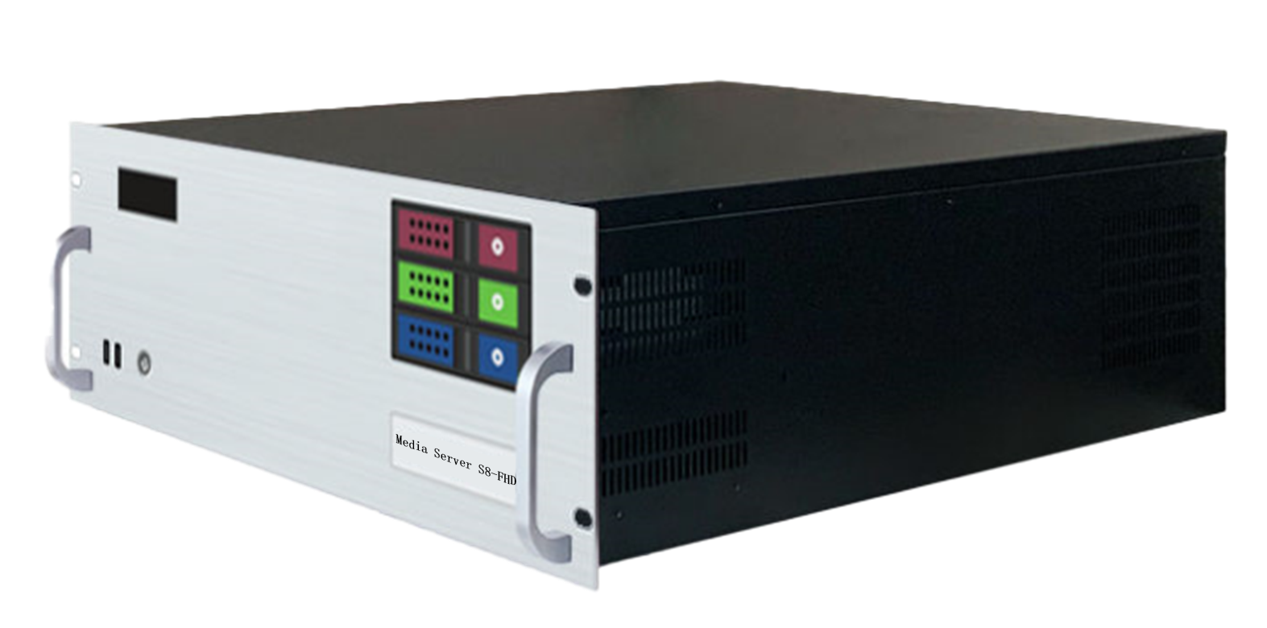

Specification Document

**Media Broadcast Control Server**

**S8-FHD**

**Revision History**

|  |  |  |
| --- | --- | --- |
| Release version | Release date | Update Notes |
| V1.0 | 2021-08-31 | • First release |
| V1.1 | 2022-06-15 | • Updated power/graphics/VGA/COM interfaces |
| V1.2 | 2022-09-06 | • Updated appearance parameters/system introduction |
| V1.3 | 2023-05-22 | • Add HDMI monitor port  • Add DVI monitor port  • Add a T1000 graphics card for monitor display  • Change the broadcast control system to the windowed version  • External BNC SYNC synchronization card port |

**Product Introduction**

S8-FHD media broadcast control server is a multimedia integrated broadcast control server for large-scale LED broadcast control scene applications such as multimedia exhibition halls, banquet halls, and live performances. It has the signal processing capabilities of traditional multi-screen splicing processors, and integrates the media editing and broadcasting functions and lighting choreography control functions of professional stage performances. It can not only complete high-quality ultra-large resolution point-to-point display, but also realize a variety of display ideas. The S8-FHD media broadcast control server is equipped with professional LED broadcast control software, providing users with convenient scene management and professional LED human-computer interaction interface, which is suitable for performing arts, exhibitions, large-scale buildings and various creative display application scenarios.

**Certification**

CCC、CE、Rohs

If the product does not have the relevant certification of the country or region to which it is sold, please contact us for confirmation or processing as soon as possible, otherwise, if the relevant legal risks are caused, the customer shall bear it or we have the right to recover.

**Product Features**

* The maximum load width of the single-port output port is 8192Px, the maximum height is 8192Px, and it can be customized within the range of 8.84 million Px.
* The whole machine can carry 70 million pixels and supports customization.
* Hardware decoding capability: multi-channel 2K/4K/8K hardware decoding.
* Video input: 4K/2K input is optional.
* Number of input channels: 1-4 HDMI/DVI/SDI optional.
* Support HDMI/DVI/SDI multiple signal inputs 2K/4K custom capture card (optional).
* Support tablet central control playback.
* Support TCP/UDP protocol network commands.
* Support any angle rotation of the screen, which is suitable for various creative display applications.
* LTC timecode synchronization.
* 1000W server power supply.
* Support 3D mapping.
* Built-in universal decoder that can decode common professional video formats such as HAP, DXV, HEVC, etc.

**Product Dimensions**

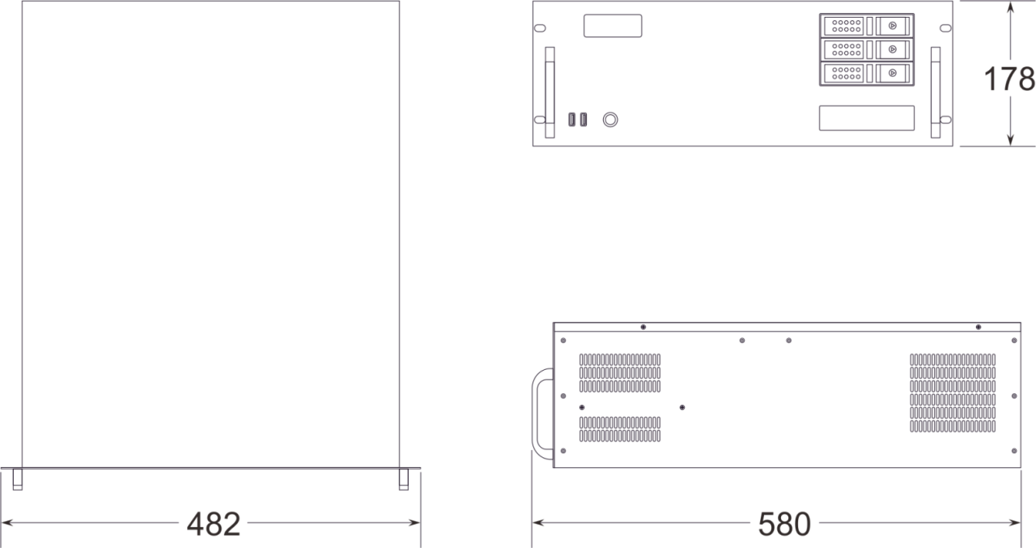

**Product** **Appearance**

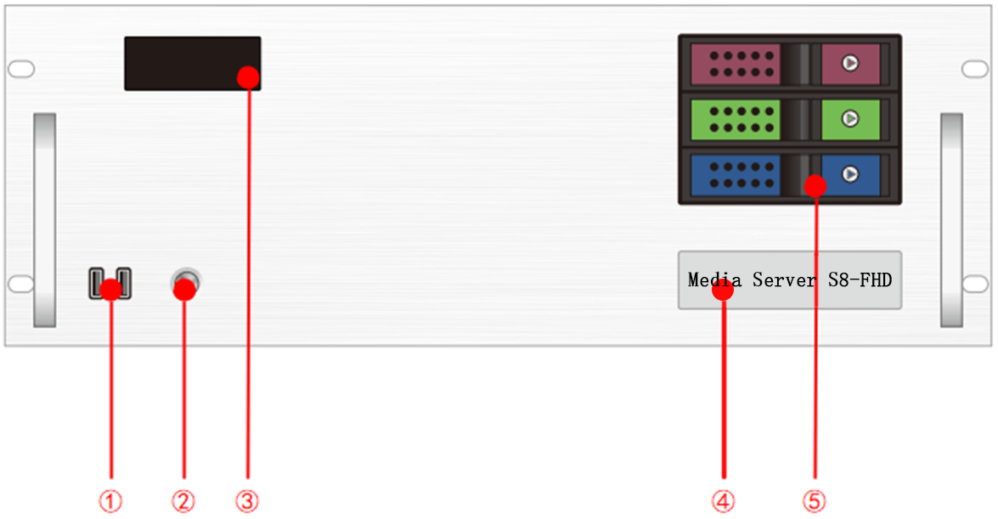

**Front Panel**

|  |  |  |  |
| --- | --- | --- | --- |
| Index | Interface | Quantity | Illustrate |
| 1 | USB | 2 | • Type-A USB3.0 |
| 2 | Power on and off button | 1 | • Power on and off button |
| 3 | Temperature control display screen | 1 | • Display server runtime, temperature, cooling fan status, and abnormal alarms |
| 4 | Identification | 1 | • Server model and name identification |
| 5 | Front hard drive enclosure | 3 | • Supports installation of 3.5-inch and 2.5-inch SATA interface hard drives |

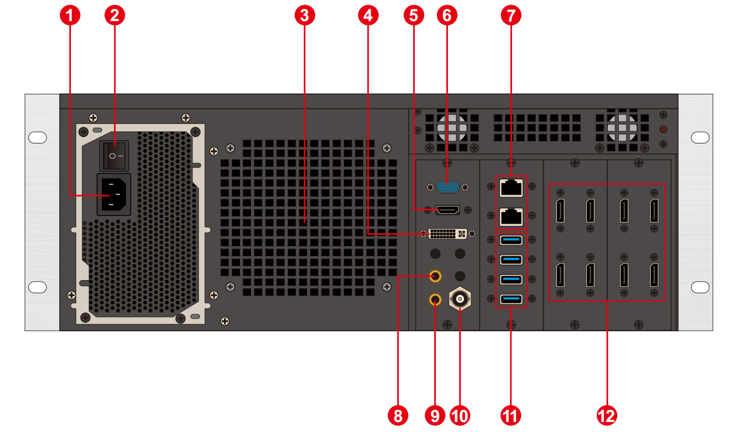

**Back Panel**

|  |  |  |  |
| --- | --- | --- | --- |
| Index | Interface | Quantity | Illustrate |
| 1 | Power input | 1 | • Power input  • 110V-240V 50/60Hz  • Alternating current |
| 2 | AC switch | 1 | • Main power switch |
| 3 | Cooling vent | 1 | • CPU water cooling fan vent |
| 4 | DVI output | 1 | • Connect to DVI monitor  • Used for operating and editing broadcast control software |
| 5 | HDMI output | 1 | • Connect to HDMI monitor  • Used for operating and editing broadcast control software |
| 6 | COM port | 1 | • COM interface  • Can connect to RS232/485 protocol serial devices |
| 7 | Ethernet port | 2 | • 1GB RJ45 port *1  • 5GB RJ45 port *1 |
| 8 | Audio output | 1 | • 3.5㎜ standard audio output port |
| 9 | Microphone | 1 | • 3.5㎜ standard audio output port  • Can connect to microphone input audio  • Can accept audio timecode |
| 10 | Synchronization signal input | 1 | • Connect to external synchronization signal  • BNC interface |
| 11 | USB | 4 | • Type-A USB 3.0  • Can connect to mouse, keyboard, USB drive, external hard drive, wireless network card, etc. |
| 12 | DP 1.2 | 4 | • Connect to monitor for displaying software editing interface  • Connect to sender card or display screen for outputting images  • Maximum output 4096*2160@60Hz |

**Device Hardware/Software**

|  |  |  |  |
| --- | --- | --- | --- |
| **Hardware Parameters** | | | |
| CPU： | Intel Xeon W-2150B@ 3.00GHz, 10 cores, 20 threads, turbo Boost up to 4.5GHz | | |
| Memory: | 32GB DDR4 RECC | | |
| Storage: | M.2 2048GB NVMe, supports hot-swappable hard drives | | |
| Output Graphics Card: | 2* NVIDIA RTX A4000 16GB Professional Graphics Card | | |
| Control Graphics Card: | NVIDIA T1000 Professional Graphics Card | | |
| Power supply: | 1000W power supply | | |
| Chassis: | 4U hot-swappable chassis | | |
| Cooler: | Water cooling (CPU), air cooling (GPU) | | |
| **Software** | | | |
| Operating system: | Windows 10 Enterprise | Broadcast Control System: | LED Broadcast Control System (Window Version) |
| **Power Supply** | | | |
| Input Power: | 110-220V AC ~50hz | | |
| Maximum Power: | 1000W | | |

**Equipment specifications**

|  |  |
| --- | --- |
| Electrical Specifications | 110-240V~ 6A 50/60Hz ;1000W maximum power |
| Installation Specifications: | 4U rack-mounted installation (according to the site situation). |
| Dimensions | 580mm (length) × 482mm (width) × 178mm (height) |
| Working environment | Temperature: 5-35°C (40°-95°F), Humidity: 5%-95% (non-condensing). |
| Storage environment | -10°C to +60°C; 0% RH to 95% RH, non-condensing |
| Package size | 678mm (length) × 548mm (width) × 265mm (height). |
| Accessories | Power Cable*1, Ethernet Cable*1, Functional checklist *1, Test report *1, Certificate of conformity *1, Packing list *1, Mouse and keyboard set *1, Wireless network card *1, DP cable *8, HDMI cable *1, Activation label *1 (attached to the front panel of the chassis) |

**Media Type**

|  |  |
| --- | --- |
| Media type | Media format |
| Video | mp4、avi、mkv、flv、mov、wmv、mpeg、mpg、m4v、webm、HAP |
| Audio | mp3、aac、flac、amr、ape、wav、wma |
| Image | jpg、jpeg、bmp、png、gif、ico |
| Text | Txt |
| Streaming | Ndi、http、rtsp、rtp、rtcp、rtmp、mms、hls |
| Web page | Any web page that can be accessed |
| Office files | PPT(1080P) |

**Notes**

Video encoding format recommendation:

• If the video is between 4K and 8K in size, with a width of 8192 or less and a height of 4320, H.265 (HEVC) or VP9 encoding is recommended.

• When the video is 4K or smaller, H.264 (AVC) encoding is recommended.

• If the video is over 8K and the width is not more than 15,360 and the height is not more than 7,680, it is recommended that the video be encoded in HAP.

For the best performance and image quality, the recommended video source bitrate is as follows:

|  |  |  |
| --- | --- | --- |
| Video resolution | 24-30 fps (standard video) | 48-60 fps (high frame video) |
| 4320P（8K） | 70-100Mbps | 100-140Mbps |
| 2160P（4K） | 35-45Mbps | 55-70Mbps |
| 1080P（2K） | 10Mbps | 16Mbps |

The above is the recommended video bitrate for SDR sources

**Optional Configurations**

Products in the configurable options require separate orders for purchase.

|  |  |
| --- | --- |
| **Name/Model** | **Specifications** |
| Sync Card  (2nd Generation) | The 2nd generation sync card must be used with high-end graphics processing cards A4000 or above.  • LED lights indicate sync connection status.  • 1×BNC interface for external sync signal input.  • 2×RJ45 interfaces for frame sync lock signal input and output. |
| HDMI Capture Card | • Optional 1-4 channel HDMI capture card.  • Maximum resolution support up to 3840*2160. |
| Encoder/Decoder | • NDI encoder supports 2K, 4K encoding and decoding.  • Network streaming media encoder supports RTSP, HLS and other streaming media encoding protocols.  • HDMI signal input.  • Supports loop output monitoring. |
| Central Control System | • ShenGong central control system APP |

**Function support**

|  |  |
| --- | --- |
| **Function** | **Description** |
| Hot Standby | Supports automatic hot standby switching |
| Media Support | Supports playback of various media such as PPT, web pages, videos, images, and audio |
| Slice Masking | Supports importing slice data, and masking functions |
| Chroma Keying | Supports chroma keying, including custom color keying |
| Cascade | Supports multi-machine cascade control |
| Frame Synchronization | Supported (requires upgrade) |
| 3D WEB Playback Control System | Supports multi-terminal control |
| 24-244 Frame Rate Selection (Frame Interpolation Playback) | Supports |
| Central Control System (Standard Edition) | Supports |
| Playback Monitoring System | Supports |
| Interactive Games | Supports |
| NDI Capture | Supports |
| Streaming Media Playback | Supports |
| LTC/NTC Timecode | Supports receiving and sending timecode |
| DMX512 | Supports recording playback and broadcast control controlled by DMX512 signals. |
| TCP/UDP Protocol | Supports sending TCP/UDP control commands and receiving TCP/UDP control commands |

**Packing List**

|  |  |  |  |
| --- | --- | --- | --- |
| Item | Quantity | Specifications | Unit |
| Server | 1 | S8-FHD | Unit |
| Power cord | 1 | 1.8 meters | Strip |
| HDMI cable | 1 | 2 meters | Strip |
| DP Cable | 8 | 2 meters | Strip |
| Wireless Network Card | 1 | USB wireless network card | Piece |
| Keyboard and mouse | 1 | Dual delphinium USB keyboard mouse | Set |
| Certificate of Conformity | 1 |  | Copy |
| Testing report | 1 |  | Copy |
| Functional Checklist | 1 |  | Copy |
| Packing List | 1 |  | Copy |

**Application Scenarios**

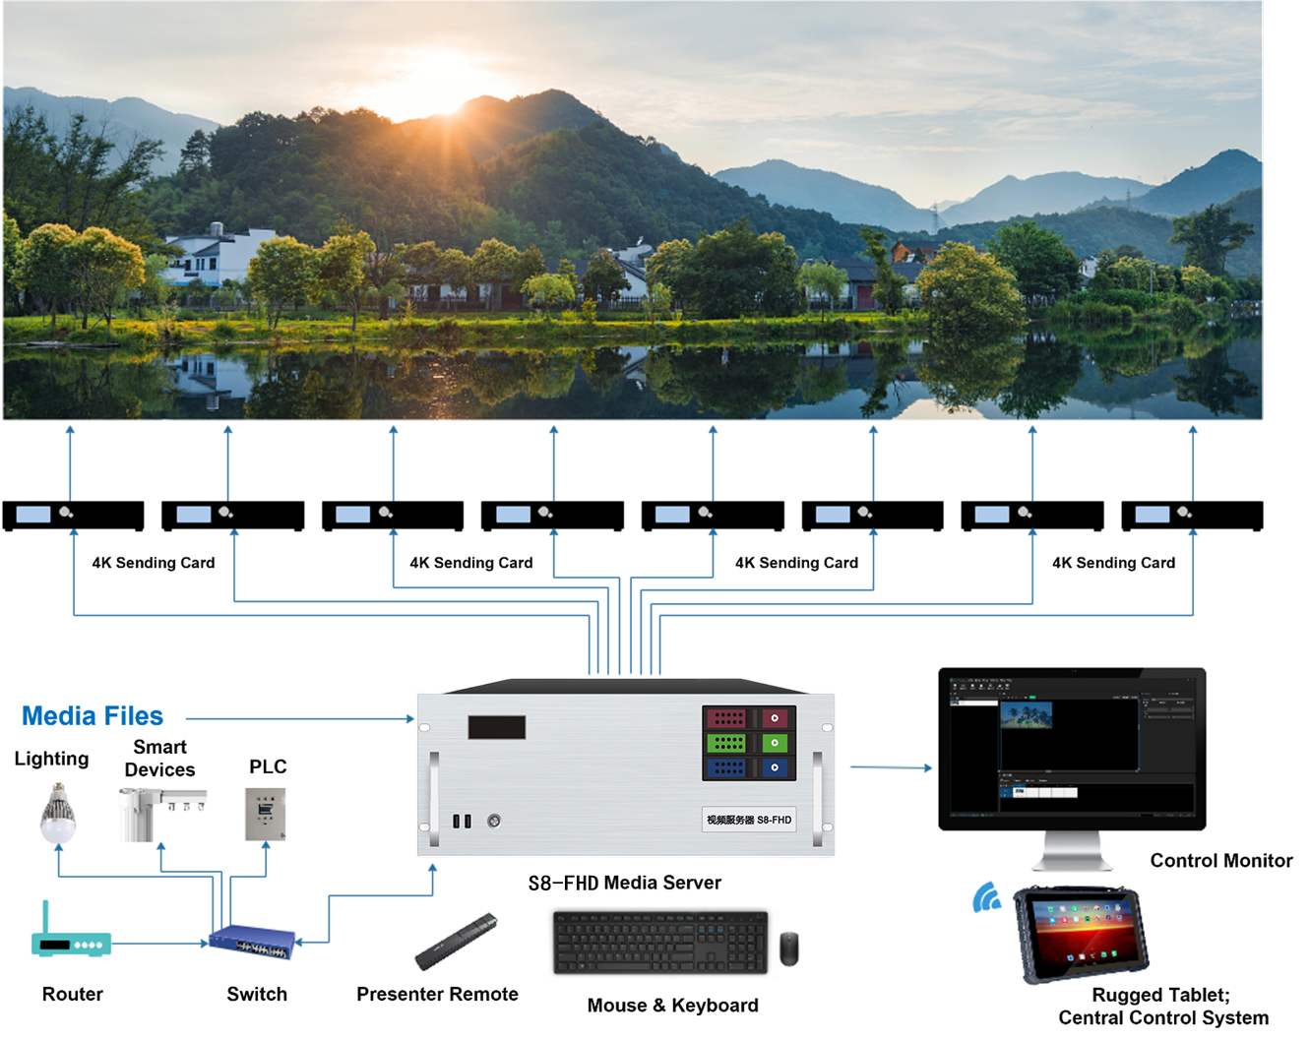

Notes

When using the device, place the device horizontally, do not flip or place it vertically.

The product can be installed in a standard 19-inch cabinet. The cabinet load requirement is at least four times the weight of all equipment in the cabinet. It needs to be installed with 4 M5 panel screws.

**Statement and Warning**

This is A Class A product, which may cause radio interference in a domestic environment. In such cases, users may be required to take practical measures against their interference.

**Copyright ©2024 Shenzhen Ruizhong Technology Co., LTD. All rights reserved.**

Without the permission of the Company, any unit or individual shall not copy, copy part or all of the content of the text document without authorization, and shall not be transmitted in any form.

**Trademark declaration**

 is a registered trademark of Ruizhong Technology.

**Statement**

We strive to be accurate and reliable in the preparation of documentation, and the content may be modified or changed at any time without notice.If you encounter any problems during use, please contact us according to the contact information in the document, and we will try our best to support you.

**Website: www.sz-ipc.com**

**Address: 301, Building 1, No. 2, Shouhe Road, Jinsha Community, Keng Zi Street, Pingshan District, Shenzhen**