

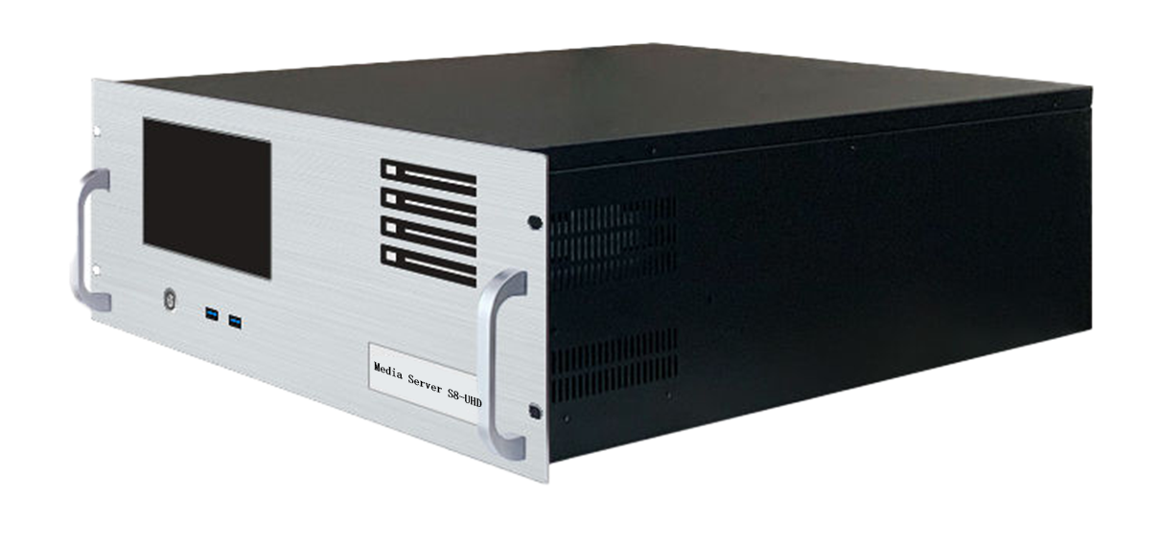

**Media Broadcast Control Server**

Specification Document

**S8-UHD**

**Revision History**

|  |  |  |
| --- | --- | --- |
| Release Version | Release Date | Update Notes |
| V1.0 | 2021-08-31 | • First release |
| V1.1 | 2022-06-15 | • Updated power/graphics/VGA/COM interfaces |
| V1.2 | 2022-09-06 | • Updated appearance parameters/system introduction |
| V1.3 | 2023-05-22 | • Add a T1000 graphics card as a display  • The broadcast control system was changed to window version |

**Product Introduction**

S8-UHD media broadcast control server is a multimedia integrated broadcast control server for large-scale LED broadcast control scene applications such as multimedia exhibition halls, banquet halls, and live performances. It has the signal processing capabilities of traditional multi-screen splicing processors, and integrates the media editing and broadcasting functions and lighting choreography control functions of professional stage performances. It can not only complete high-quality ultra-large resolution point-to-point display, but also realize a variety of display ideas. The S8-UHD media broadcast control server is equipped with professional LED broadcast control software, providing users with convenient scene management and professional LED human-computer interaction interface, which is suitable for performing arts, exhibitions, large-scale buildings and various creative display application scenarios.

**Certification**

CCC、CE、Rohs

If the product does not have the relevant certification of the country or region to which it is sold, please contact Ruizhong Technology for confirmation or processing as soon as possible, otherwise, if the relevant legal risks are caused, the customer shall bear it or Ruizhong Technology has the right to recover.

**Product Features**

* The maximum load width of the single-port output port is 8192Px, the maximum height is 8192Px, and it can be customized within the range of 8.84 million Px.
* The front 7-inch touch screen displays real-time information such as temperature, hardware utilization, and output port status.
* The whole machine can carry 70 million pixels and supports customization.
* Hardware decoding capability: multi-channel 2K/4K/8K hardware decoding.
* Video input: 4K/2K input is optional.
* Number of input channels: 1-4 HDMI/DVI/SDI optional.
* Support HDMI/DVI/SDI multiple signal inputs 2K/4K custom capture card (optional).
* Support tablet central control playback;
* Support TCP/UDP protocol network commands;
* It supports any angle rotation of the screen, which is suitable for various creative display applications;
* LTC timecode synchronization;
* 2000W redundant power supply.
* Supports 3D mapping;
* Built-in universal decoder, which can decode common and professional video formats such as HAP, DXV, HEVC, etc.

**Product Dimensions**

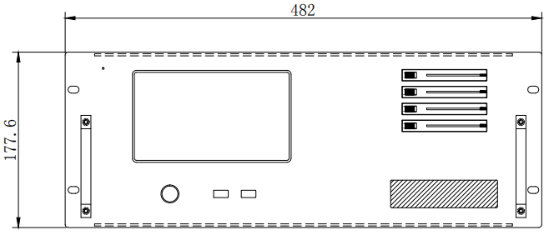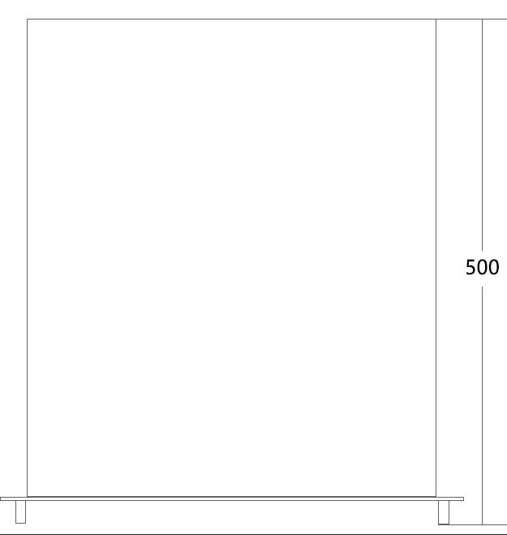

**Product** **Appearance**

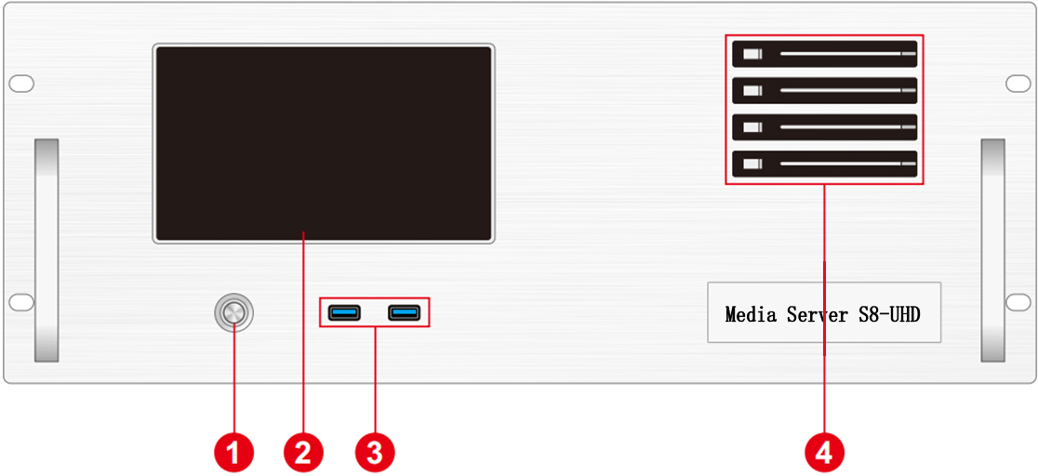

Front Panel

|  |  |  |  |
| --- | --- | --- | --- |
| Index | Interface | Quantity | Illustrate |
| 1 | Power on and off button | 1 | • Power on and off button |
| 2 | 7-inch touchscreen display | 1 | • Display system information, hardware monitoring, temperature detection, output port status |
| 3 | USB | 2 | • Type-A USB3.0 |
| 4 | Front hard drive enclosure | 4 | • 2.5-inch SATA HDD can be installed |

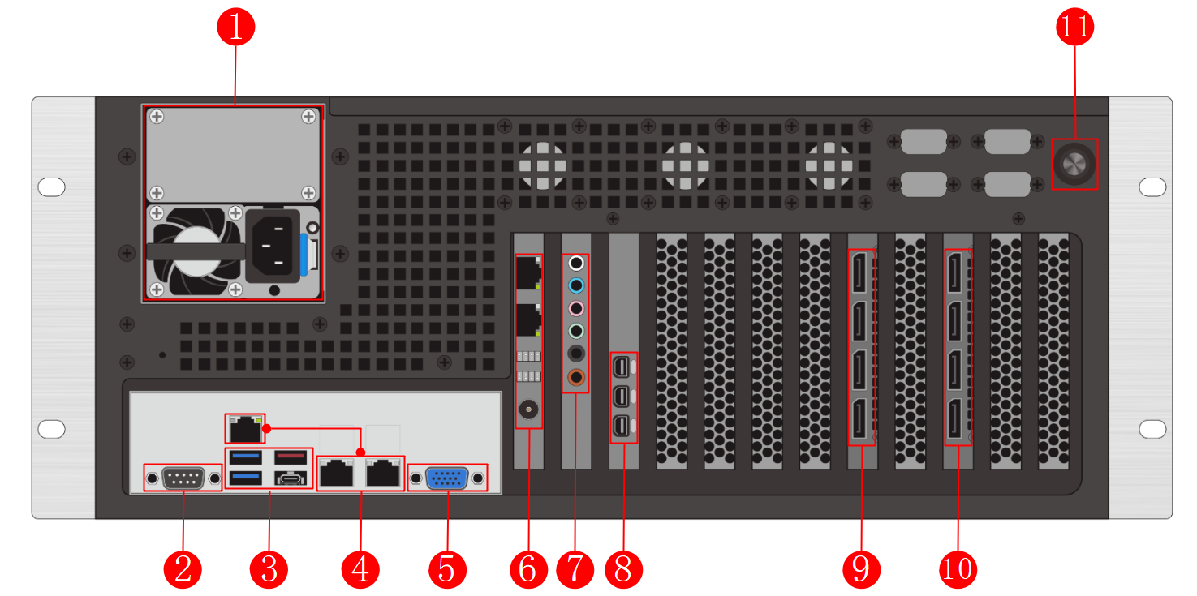

Back Panel

|  |  |  |  |
| --- | --- | --- | --- |
| Index | Interface | Quantity | Illustrate |
| 1 | Power input | 1 | • Power input  • 110V-240V 50/60Hz  • Alternating current |
| 2 | COM port | 1 | • COM port, connect to RS232 devices |
| 3 | USB | 4 | • 1×Type-C  • 2×Type-A USB3.0  • 1×Type-A USB3.1 |
| 4 | RJ45 | 3 | • 1× IPMI management port  • 2× Gigabit self-RJ45 adaptation ports |
| 5 | VGA | 1 | • Connect a VGA display  • For setting up the system only |
| 6 | Sync card | 1 | • 2× RJ45 ports for cascading between sync cards  • 1×BNC port for connecting external frame synchronization signals |
| 7 | Audio | 6 | • Grey – Side Surround Speaker Connector: In the eight-channel sound setting, it is used to connect the side surround speaker.  • Blue – Source Input: Used to connect audio outputs for recorders, speakers, etc. to this audio input port.  • Pink – Microphone Port: This port is used to connect to a microphone  • Green - Audio output port: used to connect audio receiving devices such as headphones or speakers.  • Black – Rear Surround Speaker Connector: Used to connect rear surround speakers in 4/6/8 channel audio settings.  • Orange – Center/Subwoofer Connector: In the six-channel/eight-channel audio settings, it is used to connect the center/subwoofer. |
| 8 | MiniDP | 3 | • 3× MiniDP output port  • Can be connected to a control display |
| 9 | DP1.4 port | 4 | • 4 DP1.4 ports  • It can output 4 channels of 4K video signal  • Support fusion and tiling display |
| 10 | DP1.4 port | 4 | • 4 DP1.4 ports  • It can output 4 channels of 4K video signal  • Support fusion and tiling display |
| 11 | Reset the button | 1 | • BIOS reset button  • The server restarts after pressing |

**Device Hardware/Software**

|  |  |  |  |
| --- | --- | --- | --- |
| **Hardware Parameters** | | | |
| CPU： | ® Intel Xeon ® processor Gold 5317 24 cores and 48 threads, main frequency 3.0GHz, turbo frequency 3.6GHz | | |
| Memory: | 64GB DDR4 RECC | | |
| Storage: | 3.84TB NVMe M.2 SSD with hot-swappable hard drives | | |
| Output Graphics Card: | 2× NVIDIA RTX A5000 24GB VRAM Professional Graphics Card | | |
| Control Graphics Card: | NVIDIA T1000 4GB Professional Graphics Card | | |
| Sync card | NVIDIA SYNC II Synchronization Card | | |
| Power supply: | 2000W power supply (can be upgraded to 1+1 redundant backup) | | |
| Chassis: | 4U hot-swappable chassis | | |
| Radiator: | Air-cooled heat dissipation | | |
| **Software** | | | |
| Operating system: | Windows 11 Enterprise | Broadcast Control System: | LED Broadcast Control System (Window Version) |
| **Power Supply** | | | |
| Input Power: | 110-220V AC ~50hz | | |
| Maximum Power: | 2000W | | |

**Equipment specifications**

|  |  |
| --- | --- |
| Electrical Specifications | 110-240V~ 6A 50/60Hz ;2000W maximum power |
| Installation Specifications: | 4U rack-mounted installation (according to the site situation). |
| Dimensions | 500mm (length) × 482mm (width) × 178mm (height) |
| Working environment | Temperature: 5-35°C (40°-95°F), Humidity: 5%-95% (non-condensing). |
| Storage environment | -10°C to +60°C; 0% RH to 95% RH, non-condensing |
| Package size | 678㎜ (length) * 548㎜ (width) * 265㎜ (height). |
| Accessories | Power Cable*1, Ethernet Cable*1, Mouse and Keyboard Set*1, Wireless LAN*1, DP Cable*8, MiniDP to HDMI Cable*1, MiniDP to DVI Cable*1 Activation Label*1 (Attached to the Front Panel of the Case), Functional Checklist*1, Test Report*1, Certificate of Conformity*1, Packing List*1 |

**Media Type**

|  |  |
| --- | --- |
| **Media Type** | **Media Format** |
| Video | mp4、avi、mkv、flv、mov、wmv、mpeg、mpg、m4v、webm、HAP |
| Audio | mp3、aac、flac、amr、ape、wav、wma |
| Image | jpg、jpeg、bmp、png、gif、ico |
| Text | Txt |
| Streaming | Ndi、http、rtsp、rtp、rtcp、rtmp、mms、hls |
| Web page | Any web page that can be accessed |
| Office files | PPT(1080P) |

Notes

Illustrate:

Video encoding format recommendation:

• If the video is between 4K and 8K in size, with a width of 8192 or less and a height of 4320, H.265 (HEVC) or VP9 encoding is recommended.

• When the video is 4K or smaller, H.264 (AVC) encoding is recommended.

• If the video is over 8K and the width is not more than 15,360 and the height is not more than 7,680, it is recommended that the video be encoded in HAP.

For the best performance and image quality, the recommended video source bitrate is as follows:

|  |  |  |
| --- | --- | --- |
| Video resolution | 24-30 fps (standard video) | 48-60 fps (high frame video) |
| 4320P（8K） | 70-100Mbps | 100-140Mbps |
| 2160P（4K） | 35-45Mbps | 55-70Mbps |
| 1080P（2K） | 10Mbps | 16Mbps |

The above is the recommended video bitrate for SDR sources

**Function Support**

|  |  |
| --- | --- |
| **Function** | **Description** |
| Hot Standby | Supports automatic hot standby switching |
| Media Support | Supports playback of various media such as PPT, web pages, videos, images, and audio |
| Slice Masking | Supports importing slice data, and masking functions |
| Chroma Keying | Supports chroma keying, including custom color keying |
| Cascade | Supports multi-machine cascade control |
| 3D WEB Playback Control System | Supports multi-terminal control |
| 24-244 Frame Rate Selection (Frame Interpolation Playback) | Supports |
| Control System (Standard Edition) | Supports |
| Preview Monitoring System | Supports |
| Interactive Games | Supports |
| NDI Capture | Supports |
| Streaming Media Playback | Supports |
| LTC/NTC Timecode | Supports receiving and sending timecode |
| DMX512 | Supports recording, playback, and control of DMX512 signals |
| TCP/UDP Protocol | Supports sending TCP/UDP control commands and receiving TCP/UDP control commands |

**Packing List**

|  |  |  |  |
| --- | --- | --- | --- |
| Item | Quantity | Specifications | Unit |
| Server | 1 | S8-UHD | Unit |
| Power Cord | 1 | 1.8 meters | Strip |
| MiniDP to HDMI cable | 1 | 30 cm | Strip |
| MiniDP to DVI cable | 1 | 30 cm | Strip |
| DP Cable | 8 | 2 meters | Strip |
| Wireless Network Card | 1 | USB wireless network card | Piece |
| Keyboard and mouse | 1 | Dual delphinium USB keyboard mouse | Set |
| Certificate of Conformity | 1 |  | Copy |
| Testing report | 1 |  | Copy |
| Functional Checklist | 1 |  | Copy |
| Packing List | 1 |  | Copy |

**Application Scenarios**

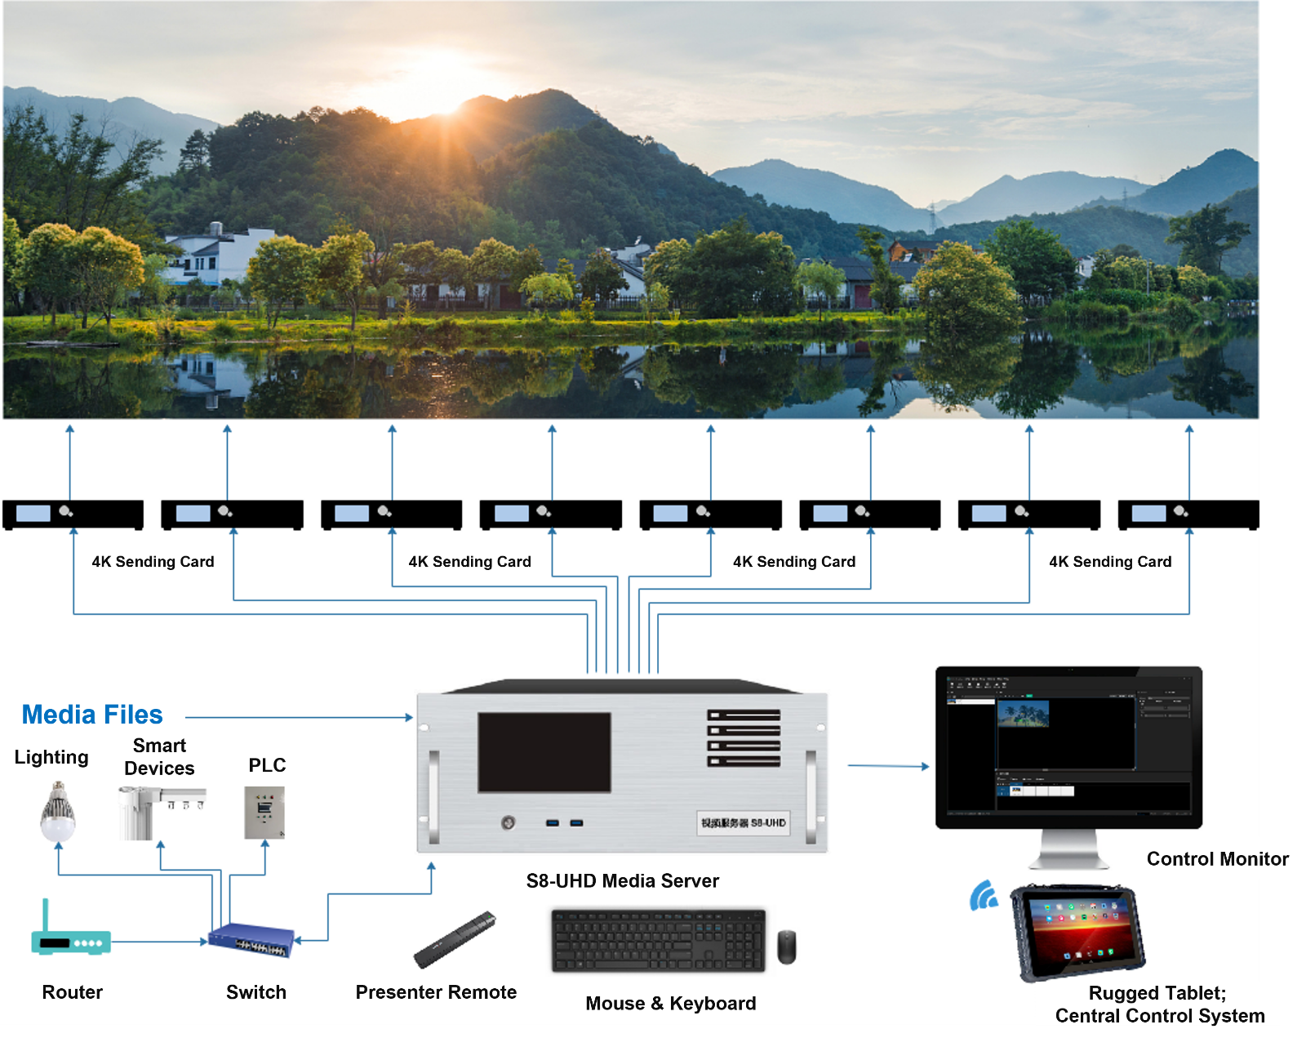

Notes

When using the device, place the device horizontally, do not flip or place it vertically.

The product can be installed in a standard 19-inch cabinet. The cabinet load requirement is at least four times the weight of all equipment in the cabinet. It needs to be installed with 4 M5 panel screws.

**Statement and Warning**

This is A Class A product, which may cause radio interference in a domestic environment. In such cases, users may be required to take practical measures against their interference.

**Copyright ©2024 Shenzhen Ruizhong Technology Co., LTD. All rights reserved.**

Without the permission of the Company, any unit or individual shall not copy, copy part or all of the content of the text document without authorization, and shall not be transmitted in any form.

**Trademark declaration**

is a registered trademark of Ruizhong Technology.

**Statement**

We strive to be accurate and reliable in the preparation of documentation, and the content may be modified or changed at any time without notice. If you encounter any problems during use, please contact us according to the contact information in the document, and we will try our best to support you.

**Website: www.sz-ipc.com**

**Address: 301, Building 1, No. 2, Shouhe Road, Jinsha Community, Keng Zi Street, Pingshan District, Shenzhen**