

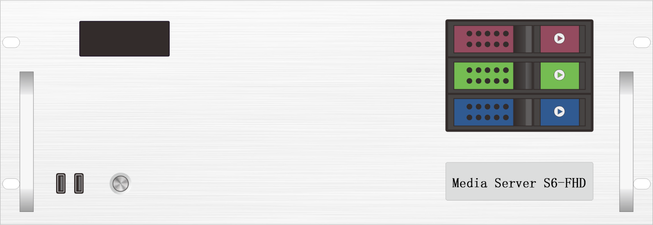

Specification Documents

**Media Broadcast Control Server**

**S6-FHD**

**Revision History**

|  |  |  |
| --- | --- | --- |
| Release version | Release Date | Update Notes |
| V1.0 | 2021-08-31 | • First release |
| V1.1 | 2022-06-15 | • Update the power/graphics /VGA/COM port |
| V1.2 | 2022-09-06 | • Update appearance parameters/system description |
| V1.3 | 2023-05-22 | • Added HDMI monitor ports  • Added DIV display port  • Added a T400 graphics card as a display  • Change the broadcast control system to window version |

**Product Introduction**

S6-FHD media broadcast control server is a multimedia integrated broadcast control server for large-scale LED broadcast control scenarios such as multimedia exhibition halls, banquet halls, and live performances. It has the signal processing capability of traditional multi-picture splicing processor, and integrates the media editing function of professional stage performance and the lighting arrangement control function. It can not only achieve high quality and ultra-high resolution point-to-point display, but also achieve a variety of display creativity. S6-FHD media broadcast control server with professional LED broadcast control software, to provide users with convenient scene management and professional LED human-computer interaction interface, suitable for performing arts, exhibitions, large buildings and a variety of creative display application scenarios.

**Certification**

CCC、CE、Rohs

If the product does not have the relevant certification of the country or region where it is sold, please contact Ruizhong Technology to confirm or deal with it at the first time, otherwise, if the relevant legal risks are caused, the customer shall bear the responsibility or Ruizhong Technology has the right to recover.

**Product Features**

* Single outlet with maximum load width 5120Px, maximum height 5120Px, in the range of 8.84 million Px user-defined.
* System load: The maximum width of a single screen is 16384Px and the maximum width is 8640Px. User-defined is supported.
* Decoding: Supports simultaneous decoding of multiple video channels.
* Video input: 4K/2K input is optional.
* Number of input channels: 1-4 HDMI/DVI/SDI Optional.
* Supports multiple HDMI/DVI/SDI signal input 2K/4K custom acquisition card (optional).
* Support tablet central control playback;
* Supports TCP/UDP network commands.
* Supports screen rotation at any Angle, suitable for a variety of creative display applications;
* 650W Server power supply.
* 3D mapping;
* Built-in universal decoder, can decode HAP, DXV, HEVC and other common and professional video formats.

**Product Dimensions**

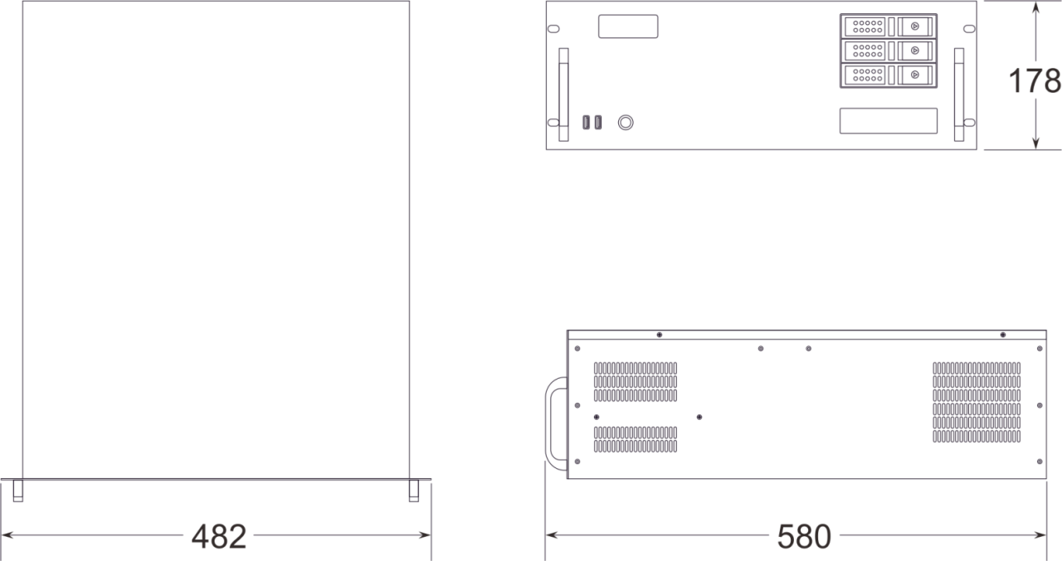

**Product Appearance**

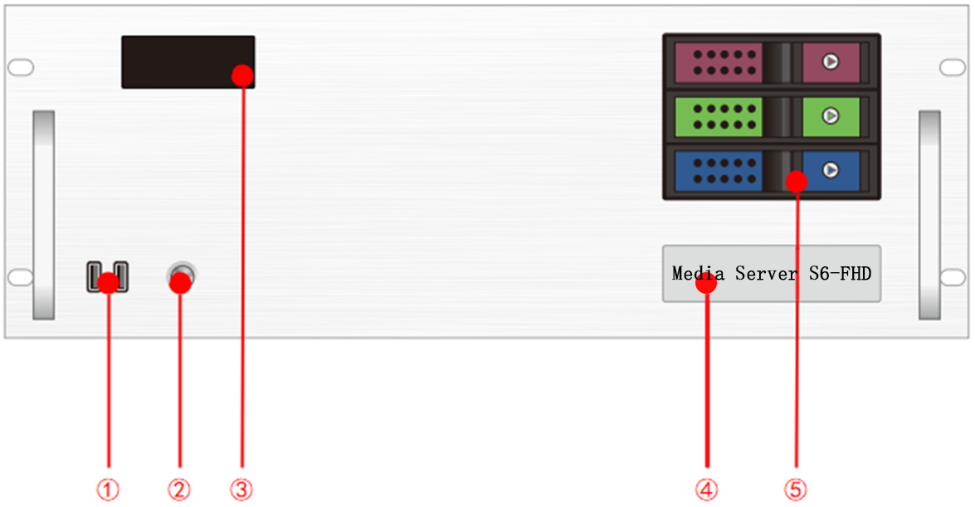

Front panel

|  |  |  |  |
| --- | --- | --- | --- |
| Index | Interface | Quantity | Description |
| 1 | USB | 2 | • Type-A USB3.0  • Connectable to mouse, keyboard |
| 2 | Switch button | 1 | • Switch button |
| 3 | Temperature control display | 1 | • Displays the server running time, temperature, cooling fan status, and abnormal alarm |
| 4 | Identification | 1 | • Identify the server model and name |
| 5 | Front hard disk box | 3 | • Can install 3.5 inch, 2.5 inch SATA interface hard disk |

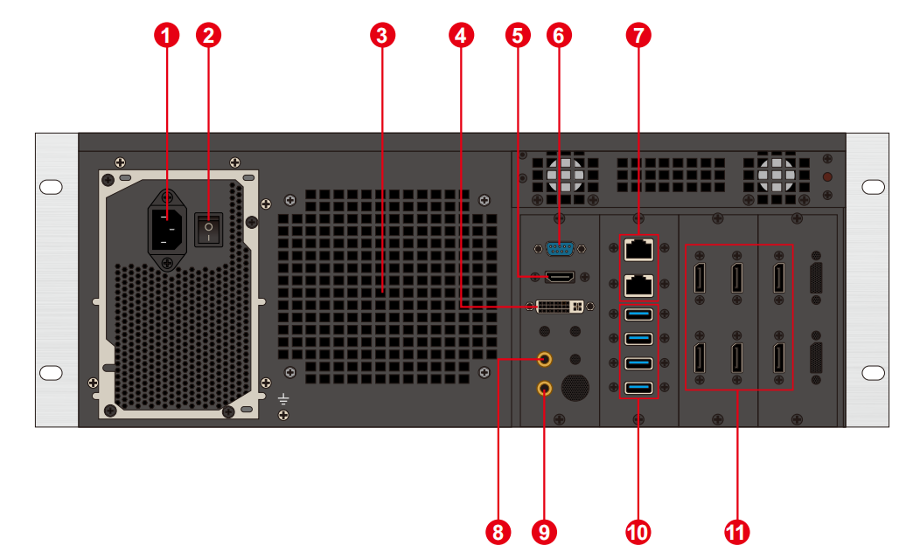

Back Panel

|  |  |  |  |
| --- | --- | --- | --- |
| Index | Interface | Quantity | Description |
| 1 | Power supply input | 1 | • Power supply input  • 110V-240V 50/60Hz  • Alternating Current |
| 2 | AC Switch | 1 | • Main power switch |
| 3 | Heat vent | 1 | • Heat dissipation port of the CPU water-cooled radiator fan |
| 4 | DVI output | 1 | • Connect DVI monitor  • Used to operate and edit broadcast control software |
| 5 | HDMI output | 1 | • Connect to HDMI display  • Used to operate and edit broadcast control software |
| 6 | COM port | 1 | • COM interface  • Can connect RS232/485 protocol serial device |
| 7 | Ethernet ports | 2 | • 1GB RJ45 port *1  • 5GB RJ45 port *1 |
| 8 | Audio output | 1 | • 3.5mm standard audio output |
| 9 | Microphone | 1 | • 3.5mm standard audio output  • Microphone can be connected to input audio |
| 10 | USB | 4 | • Type-A USB3.0  • Can connect mouse, keyboard, U disk, mobile hard disk, wireless network card, etc. |
| 11 | DP1.2 | 6 | • Connect the monitor to display the software editing interface  • Connect the sending card or display for output screen  • Maximum output 4096*2160@60Hz |

**Device Hardware/Software**

|  |  |  |  |
| --- | --- | --- | --- |
| **Hardware parameter** | | | |
| CPU | Intel Xeon W-2150B@ 3.0GHz 10 Core 20 threads at 4.5GHz | | |
| Memory | 16GB DDR4 RECC | | |
| Storage | M.2 512GB Nvme, which can be installed with a hot swappable hard drive | | |
| Output graphics card | AMD Radeon Pro W5700 8GB professional graphics card | | |
| Control graphics card | NVIDIA T400 4GB professional graphics card | | |
| Power Supply | 650W | | |
| Chassis | 4U hot-swap chassis | | |
| Cooler | Water cooling (CPU), Air cooling (GPU) | | |
| **Software** | | | |
| Operating system: | Windows 10 Enterprise Edition | Broadcast control system: | LED broadcast control system (window version) |
| **Power Supply** | | | |
| Input power supply: | 110-220V AC ~ 50hz | | |
| Maximum power: | 650W | | |

**Equipment Specification**

|  |  |
| --- | --- |
| Electrical specification | 110-240V~ 6A 50/60Hz; 650W maximum power |
| Installation specification | 4U rack mounting (based on site conditions) |
| Dimensions | 580㎜(length)×482㎜(width)×178㎜(height) |
| Working environment | Temperature: 5-35°C (40°-95°F), humidity: 5%-95% (non-condensing) |
| Storage environment | -10℃ ~ +60℃; 0%RH to 95%RH, non-condensing |
| Packing size | 678㎜(length)×548㎜(width)×265㎜(height) |
| Accessories | Power cable *1, ethernet cable *1, functional checklist *1, test report *1, certificate *1, packing list *1, mouse and keyboard set *1, wireless network card *1, DP cable *6, HDMI cable *1, activation label *1 (attached to the front panel of the chassis) |

**Media Type**

|  |  |
| --- | --- |
| **Media Type** | **Media Format** |
| Video | mp4、avi、mkv、flv、mov、wmv、mpeg、mpg、m4v、webm、HAP |
| Audio | mp3、aac、flac、amr、ape、wav、wma |
| Picture | jpg、jpeg、bmp、png、gif、ico |
| Text | Txt |
| Streaming media | Ndi、http、rtsp、rtp、rtcp、rtmp、mms、hls |
| Web page | Supports access to any web page |
| Office Files | PPT、Word |

Notes

Recommended video encoding formats:

• When the video size is above 4K, 8K or below, and the width does not exceed 8192 and the height does not exceed 4320, it is recommended to use H.265 (HEVC) encoding or VP9 encoding.

• When the video is 4K or below, H.264 (AVC) encoding is recommended.

• HAP encoding is recommended when the video is larger than 8K and the width is less than 15360 and the height is less than 7680.

For the best performance and picture quality, the recommended video source rate is as follows:

|  |  |  |
| --- | --- | --- |
| **Video resolution** | **24-30 FPS (standard video)** | **48-60 FPS (high frame video)** |
| 4320P（8K） | 70-100Mbps | 100-140Mbps |
| 2160P（4K） | 35-45Mbps | 55-70Mbps |
| 1080P（2K） | 10Mbps | 16Mbps |

The above is the recommended video bit-rate for SDR source.

**Functional Support**

|  |  |
| --- | --- |
| **Feature** | **Description** |
| Media support | Support PPT, web pages, videos, pictures, audio and other media playback |
| Slice Mask | Support the import section data, support functions of mask |
| Central control System (Standard Edition) | Support |
| Echo monitoring system | Support |
| Interactive game | Support |
| NDI acquisition | Support |
| Streaming media | Support |
| TCP/UDP protocol | It supports sending TCP/UDP control commands and receiving TCP/UDP control commands. |

**Packing List**

|  |  |  |  |
| --- | --- | --- | --- |
| Item | Quantity | Quantity | Unit |
| Server | 1 | S6-FHD | Unit |
| Power cord | 1 | 1.8m | Strip |
| HDMI cable | 1 | 2m | Strip |
| DP cable | 6 | 2m | Strip |
| Wireless network card | 1 | USB wireless card | Piece |
| Keyboard and mouse | 1 | Dual Swift USB keyboard and mouse | Set |
| Certificate | 1 |  | Copy |
| Test report | 1 |  | Copy |
| Functional checklist | 1 |  | Copy |
| Packing list | 1 |  | Copy |

Notes

When using the device, place it horizontally. Do not turn it over or place it vertically.

The product can be installed in a 19-inch standard cabinet. The cabinet must bear at least four times the weight of all the devices in the cabinet. Use four M5 panel screws to secure the installation.

**Statement and Warning**

This is A Class A product, which may cause radio interference in a domestic environment. In such cases, users may be required to take practical measures against their interference.

**Copyright ©2024 Shenzhen Ruizhong Technology Co., LTD. All rights reserved.**

Without the permission of the Company, any unit or individual shall not copy, copy part or all of the content of the text document without authorization, and shall not be transmitted in any form.

**Trademark declaration**

 is a registered trademark of Ruizhong Technology.

**Statement**

We strive to be accurate and reliable in the preparation of documentation, and the content may be modified or changed at any time without notice.If you encounter any problems during use, please contact us according to the contact information in the document, and we will try our best to support you.

**Website: www.sz-ipc.com**

**Address: 301, Building 1, No. 2, Shouhe Road, Jinsha Community, Keng Zi Street, Pingshan District, Shenzhen**