

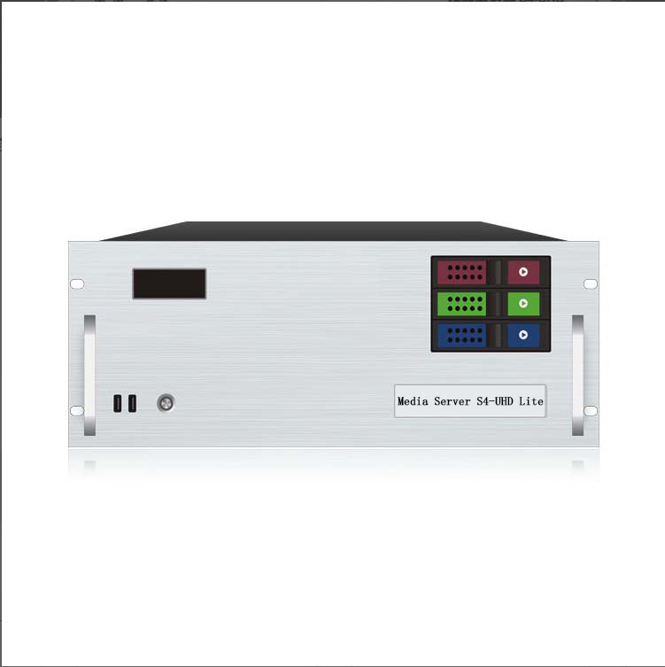

**Media Broadcast Control Server**

**S4-UHD Lite**

Specification Document

**Revision History**

|  |  |  |
| --- | --- | --- |
| Release version | Release date | Update Notes |
| V1.0 | 2021-08-31 | • First release |
| V1.1 | 2022-06-15 | • Update the power/graphics /VGA/COM port |
| V1.2 | 2022-09-06 | • Updated appearance parameters/System description |
| V1.3 | 2023-06-13 | • Add HDMI monitor ports |
| V1.4 | 2023-07-25 | • Motherboard upgraded to EAMB-1590 C246 chip-set  • Processor upgrade to Intel Xeon E-2174G  • Upgrade the graphics card to NVIDIA RTX A2000 6GB |

**Product Introduction**

S4-UHD Lite media broadcast control server is a multimedia integrated broadcast control server for large-scale LED broadcast control scenarios such as multimedia exhibition halls, banquet halls, and live performances. It has the signal processing capability of traditional multi-picture splicing processor, and integrates the media editing function of professional stage performance and the lighting arrangement control function. It can not only achieve high quality and ultra-high resolution point-to-point display, but also achieve a variety of display creativity. S4-UHD Lite media broadcast control server with professional LED broadcast control software, to provide users with convenient scene management and professional LED human-computer interface, suitable for performing arts, exhibitions, large buildings and a variety of creative display application scenarios.

**Certification**

CCC、CE、Rohs

If the product does not have the relevant certification of the country or region to which it is sold, please contact us for confirmation or processing as soon as possible, otherwise, if the relevant legal risks are caused, the customer shall bear it or we has the right to recover.

**Product Features**

* Single outlet with maximum load width 8192Px, maximum height 8192Px, in the range of 8.84 million Px user-defined.
* Machine load: maximum width of single screen 16384Px, maximum 4320Px, can be customized.
* Hardware decoding capability: 1 channel 8K hard decoding or 4 channel 4K hard decoding, support multi-channel 2K hard decoding.
* Video input: 4K/2K input is optional.
* Number of input channels: 1-4 HDMI/DVI/SDI Optional.
* Supports multiple HDMI/DVI/SDI signal input 2K/4K custom acquisition card (optional).
* Support tablet central control playback;
* Supports TCP/UDP network commands.
* Supports screen rotation at any Angle, suitable for a variety of creative display applications;
* LTC Time code synchronization;
* 650W Server power supply.
* 3D mapping;
* Built-in universal decoder, can decode HAP, DXV, HEVC and other common and professional video formats.

**Product Dimensions**

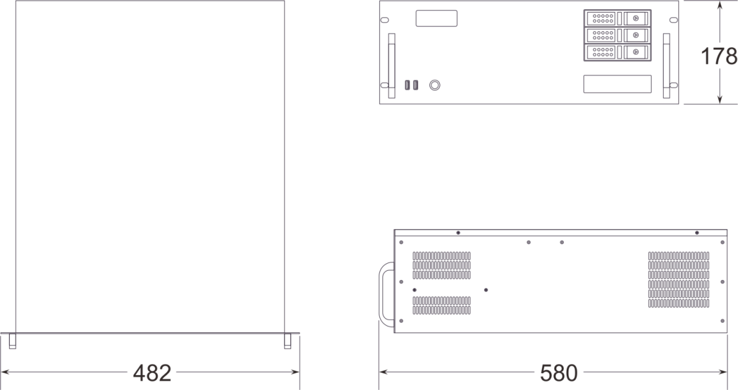

**Product Appearance**

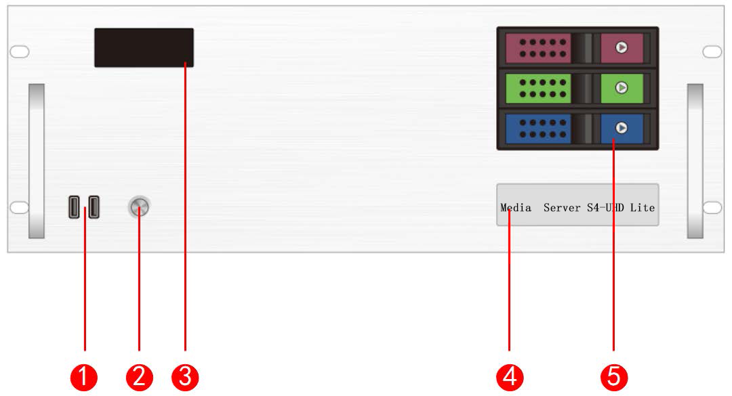

Front Panel

|  |  |  |  |
| --- | --- | --- | --- |
| Index | Interface | Quantity | Illustrate |
| 1 | USB | 2 | • Type-A USB3.0 *2  • Connectable to mouse, keyboard |
| 2 | Switch buttons | 1 | • Switch button |
| 3 | Temperature control display screen | 1 | • Displays server runtime, temperature, fan status, abnormal alarms |
| 4 | Identification | 1 | • Server model and name identification |
| 5 | Front hard drive bay | 3 | • Installable with 3.5-inch, 2.5-inch SATA interface hard drives |

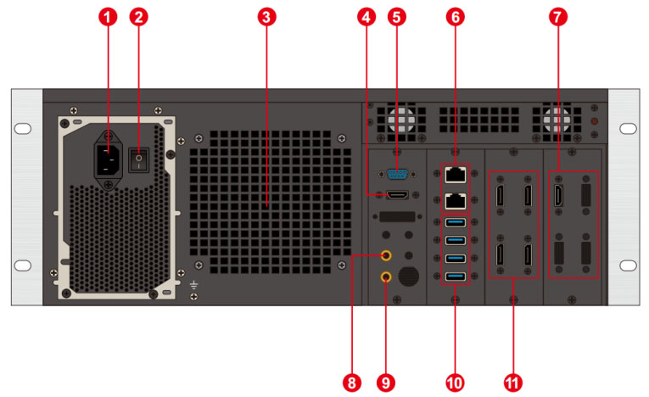

Back Panel

|  |  |  |  |
| --- | --- | --- | --- |
| Index | Interface | Quantity | Illustrate |
| 1 | Power input | 1 | • Power input  • 110V-240V 50/60Hz  • AC power |
| 2 | AC switch | 1 | • Power master switch |
| 3 | Heat vent | 1 | • CPU liquid cooling radiator fan heat dissipation port |
| 4 | HDMI output | 1 | • Connect to HDMI monitor  • Used for operating editing and control software |
| 5 | COM port | 1 | • COM interface  • Connects to RS232/485 protocol serial port devices |
| 6 | Network ports | 2 | • 1GB RJ45 ports |
| 7 | HDMI input | 4 | • Connects to HDMI signal input  • Maximum resolution 1920*1080 |
| 8 | Audio output | 1 | • 3.5mm standard audio output |
| 9 | Microphone | 1 | • 3.5mm standard audio output  • Connects to microphone input audio  • Accepts audio timecode |
| 10 | USB | 4 | • Type-A USB3.0 *4  • Connects to mouse, keyboard, USB drive, external hard drive, wireless network card, etc. |
| 11 | DP1.2 | 4 | • Connects to monitor for displaying software editing interface  • Connects to sending card or display screen for outputting images  • Maximum output 4096*2160@60Hz |

**Device Hardware/Software**

|  |  |  |  |
| --- | --- | --- | --- |
| **Hardware Parameters** | | | |
| CPU | The Intel ® Xeon ® E-2174G processor has an 8-meter cache with a base frequency of 3.8GHz and up to 4.70 GHz | | |
| Memory | 16GB DDR4 | | |
| Storage | 500GB SSD solid-state drive, supports additional hot-swappable hard drives | | |
| Output Graphics Card | NVIDIA RTX A2000 6GB professional graphics card | | |
| Control Graphics Card | INTEL P630 | | |
| Power supply | Great Wall 650W | | |
| Chassis | 4U hot-swappable chassis | | |
| Radiator | Water-cooled (CPU), air-cooled (GPU) | | |
| **Software** | | | |
| Operating system | Windows 10 Enterprise | Broadcast Control System | LED Broadcast Control System (Window Version) |
| **Power supply** | | | |
| Input Power | 110-220V AC ~ 50Hz | | |
| Maximum Power | 650W | | |

**Equipment specifications**

|  |  |
| --- | --- |
| Electrical Specifications | 110-240V~ 6A 50/60Hz ；650W maximum power |
| Installation Specifications | 4U rack-mounted installation (according to the site situation). |
| Dimensions | 580mm (length) × 482mm (width) × 178mm (height) |
| Working environment | Temperature: 5-35°C (40°-95°F), Humidity: 5%-95% (non-condensing). |
| Storage environment | -10℃～+60℃ ；0%RH～95%RH，non-condensing |
| Package size | 678mm (length) × 548mm (width) × 265mm (height). |
| Fittings | Power cord *1, ethernet cable *1, functional checklist *1, test report *1, certificate of conformity *1, packing list *1, mouse and keyboard set *1, wireless network card *1, DP cable *4, HDMI cable *1, activation label *1 (attached to the front panel of the chassis) |

**Media Type**

|  |  |
| --- | --- |
| **Media Type** | **Media Format** |
| Video | mp4、avi、mkv、flv、mov、wmv、mpeg、mpg、m4v、webm、HAP |
| Audio | mp3、aac、flac、amr、ape、wav、wma |
| Image | jpg、jpeg、bmp、png、gif、ico |
| Text | Txt |
| Streaming | Ndi、http、rtsp、rtp、rtcp、rtmp、mms、hls |
| Web page | Any web page that can be accessed |
| Office files | PPT (1080P) |

Notes

Illustrate:

Video encoding format recommendation:

• If the video is between 4K and 8K in size, with a width of 8192 or less and a height of 4320, H.265 (HEVC) or VP9 encoding is recommended.

• When the video is 4K or smaller, H.264 (AVC) encoding is recommended.

• If the video is over 8K and the width is not more than 15,360 and the height is not more than 7,680, it is recommended that the video be encoded in HAP.

For the best performance and image quality, the recommended video source bitrate is as follows:

|  |  |  |
| --- | --- | --- |
| **Video resolution** | **24-30 fps (standard video)** | **48-60 fps (high frame video)** |
| 4320P(8K) | 70-100Mbps | 100-140Mbps |
| 2160P(4K) | 35-45Mbps | 55-70Mbps |
| 1080P(2K) | 10Mbps | 16Mbps |

The above is the recommended video bitrate for SDR sources

**Function Support**

|  |  |
| --- | --- |
| **Function** | **Illustrate** |
| Media support | Supports playback of various media such as PPT, web pages, videos, images, and audio |
| 3D WEB broadcast control system | Supports multi-terminal control |
| 24-244 Frame Rate Selection (Frame Interpolation Playback) | Supports |
| Central Control System (Standard Version) | Supports |
| Preview Monitoring System | Supports |
| Interactive games | Supports |
| NDI Capture | Supports |
| Streaming Media Playback | Supports |
| LTC/NTC Timecode | Supports receiving and sending timecode |
| DMX512 | Supports recording, playback, and control of DMX512 signals |
| TCP/UDP Protocol | Supports sending TCP/UDP control commands and receiving TCP/UDP control commands |

**Packing list**

|  |  |  |  |
| --- | --- | --- | --- |
| Item | Quantity | Specification | Unit |
| Host | 1 | S4-UHD lite | Unit |
| Power cord | 1 | 1.8 meters | Strip |
| HDMI cable | 1 | 2 meters | Strip |
| DP line | 3 | 2 meters | Strip |
| Wireless network card | 1 | USB wireless network card | Piece |
| Keyboard and mouse | 1 | Dual delphinium USB keyboard mouse | Set |
| Certificate | 1 |  | Copy |
| Test report | 1 |  | Copy |
| Functional checklist | 1 |  | Copy |
| Packing list | 1 |  | Copy |

**Notes**

When using the device, place the device horizontally, do not flip or place it vertically.

The product can be installed in a standard 19-inch cabinet. The cabinet load requirement is at least four times the weight of all equipment in the cabinet. It needs to be installed with 4 M5 panel screws.

**Statement and Warning**

This is A Class A product, which may cause radio interference in a domestic environment. In such cases, users may be required to take practical measures against their interference.

**Copyright ©2024 Shenzhen Ruizhong Technology Co., LTD. All rights reserved.**

Without the permission of the Company, any unit or individual shall not copy, copy part or all of the content of the text document without authorization, and shall not be transmitted in any form.

**Trademark declaration**

is a registered trademark of Ruizhong Technology.

**Statement**

We strive to be accurate and reliable in the preparation of documentation, and the content may be modified or changed at any time without notice.If you encounter any problems during use, please contact us according to the contact information in the document, and we will try our best to support you.

**Website: www.sz-ipc.com**

**Address: 301, Building 1, No. 2, Shouhe Road, Jinsha Community, Keng Zi Street, Pingshan District, Shenzhen**