

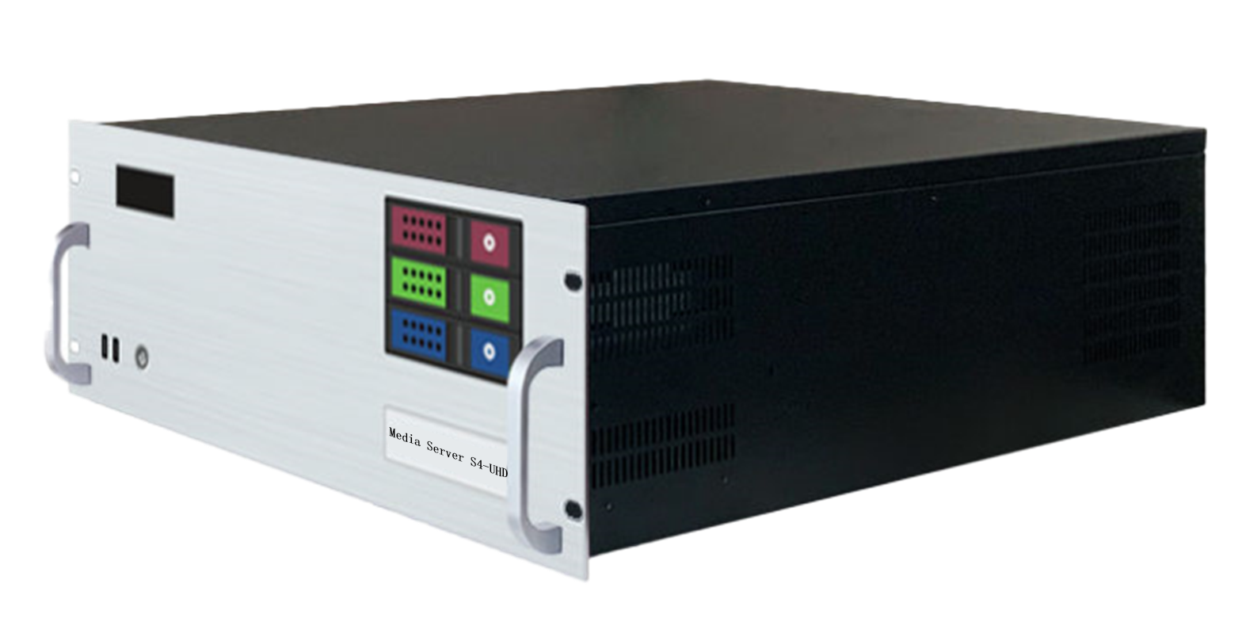

Specification Document

**Media Broadcast Control Server**

**S4-UHD**

**Revision History**

|  |  |  |
| --- | --- | --- |
| Release version | Release Date | Update Notes |
| V1.0 | 2021-08-31 | • First release |
| V1.1 | 2022-06-15 | • Updated power/graphics/VGA/COM interfaces |
| V1.2 | 2022-09-06 | • Updated appearance parameters/system introduction |
| V1.3 | 2023-05-22 | • Add HDMI display port  • Add DIV display port  • Add a T400 graphics card as a display  • The broadcast control system was changed to window version |

**Product Introduction**

S4-UHD media broadcast control server is a multimedia integrated broadcast control server for large-scale LED broadcast control scene applications such as multimedia exhibition halls, banquet halls, and live performances. It has the signal processing capabilities of traditional multi-screen splicing processors, and integrates the media editing and broadcasting functions and lighting choreography control functions of professional stage performances. It can not only complete high-quality ultra-large resolution point-to-point display, but also realize a variety of display ideas. The S4-UHD media broadcast control server is equipped with professional LED broadcast control software, providing users with convenient scene management and professional LED human-computer interaction interface, which is suitable for performing arts, exhibitions, large-scale buildings and various creative display application scenarios.

**Certification**

CCC、CE、Rohs

If the product does not have the relevant certification of the country or region to which it is sold, please contact Ruizhong Technology for confirmation or processing as soon as possible, otherwise, if the relevant legal risks are caused, the customer shall bear it or Ruizhong Technology has the right to recover.

**Product Features**

* Single output port supports a maximum width of 8192 pixels and a maximum height of 8192 pixels, customizable within the range of 8.84 million pixels.
* Overall load capacity: Single screen up to 16384 pixels wide and 8640 pixels high, customizable within the range of 35.39 million pixels, with a total load capacity of 35.39 million pixels.
* Hardware decoding capabilities: 1 channel of 8K hardware decoding or 4 channels of 4K hardware decoding, supporting multiple channels of 2K hardware decoding.
* Video input: Optional 4K/2K input.
* Number of inputs: 1-4 channels of HDMI/DVI/SDI optional.
* Supports multiple signal inputs including HDMI/DVI/SDI 2K/4K custom capture cards (optional).
* Supports control and playback via tablet control.
* Supports TCP/UDP protocol network commands.
* Supports rotation of images at any angle, suitable for various creative display applications.
* LTC timecode synchronization.
* 650W server power supply.
* Supports 3D mapping.
* Built-in universal decoder capable of decoding common and professional video formats such as HAP, DXV, HEVC, etc.

**Product Dimensions**

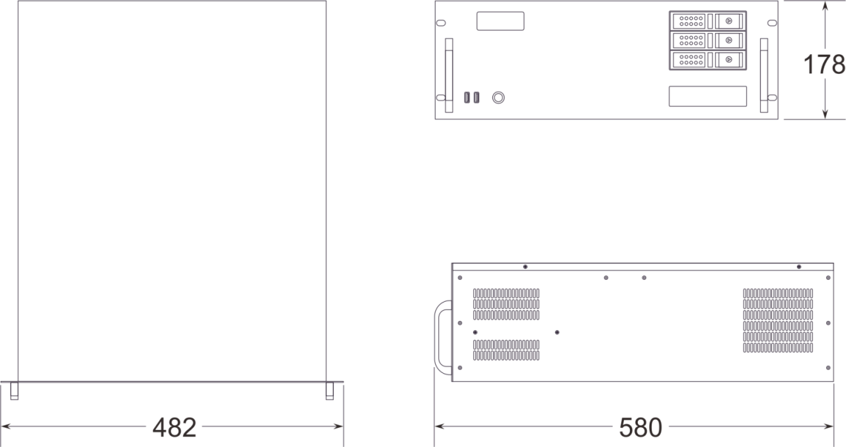

**Product Appearance**

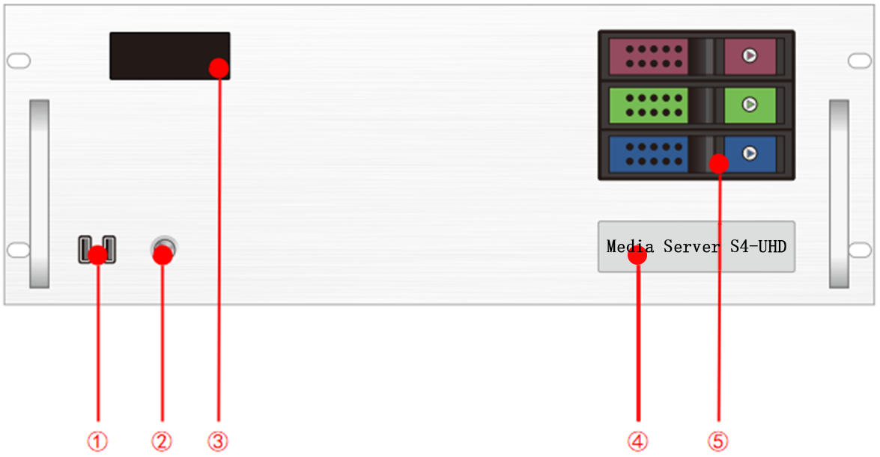

Front Panel

|  |  |  |  |
| --- | --- | --- | --- |
| Index | Interface | Quantity | Illustrate |
| 1 | USB | 2 | • Type-A USB3.0  • Connectable to mouse, keyboard |
| 2 | Switch button | 1 | • Switch button |
| 3 | Temperature control display screen | 1 | • Displays server runtime, temperature, fan status, abnormal alarms |
| 4 | Identification | 1 | • Server model and name identification |
| 5 | Front hard drive bay | 3 | • Installable with 3.5-inch, 2.5-inch SATA interface hard drives |

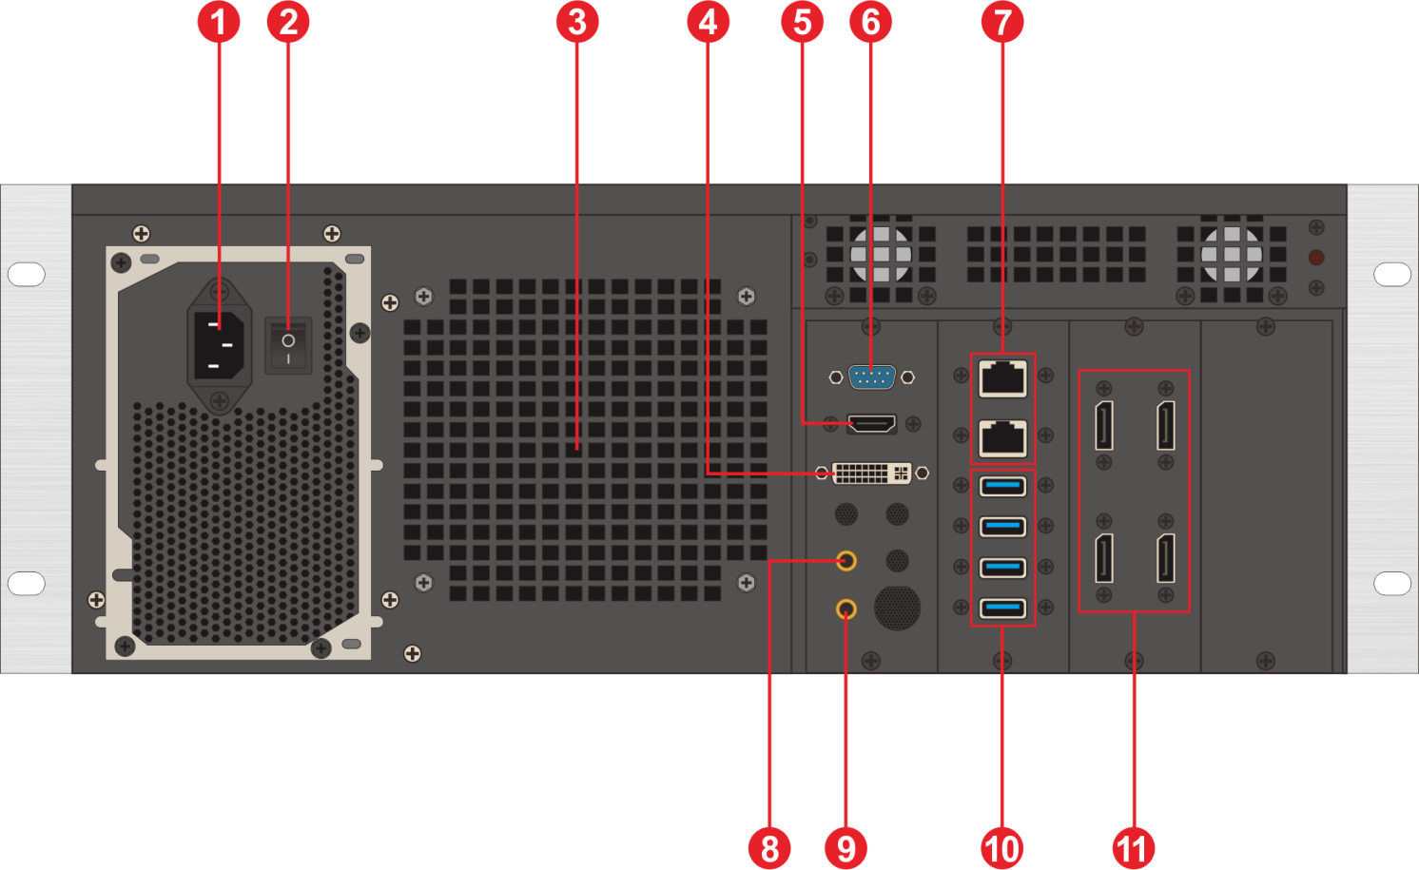

Back Panel

|  |  |  |  |
| --- | --- | --- | --- |
| Index | Interface | Quantity | Illustrate |
| 1 | Power input | 1 | • Power input  • 110V-240V 50/60Hz  • AC power |
| 2 | AC switch | 1 | • Power master switch |
| 3 | Cooling vent | 1 | • CPU water-cooling radiator fan cooling vent |
| 4 | DVI output | 1 | • Connects to DVI monitor  • Used for operating editing and control software |
| 5 | HDMI output | 1 | • Connect to HDMI monitor  • Used for operating editing and control software |
| 6 | COM port | 1 | • COM interface  • Connects to RS232/485 protocol serial port devices |
| 7 | Ethernet ports | 2 | • 1GB RJ45 port*1  • 5GB RJ45 port*1 |
| 8 | Audio output | 1 | • 3.5mm standard audio output |
| 9 | Microphone | 1 | • 3.5mm standard audio output  • Connects to microphone input audio  • Accepts audio timecode |
| 10 | USB | 4 | • Type-A USB3.0 *4  • Connects to mouse, keyboard, USB drive, external hard drive, wireless network card, etc. |
| 11 | DP1.2 | 4 | • Connects to monitor for displaying software editing interface  • Connects to sending card or display screen for outputting images  • Maximum output 4096*2160@60Hz |

**Device Hardware/Software**

|  |  |  |  |
| --- | --- | --- | --- |
| **Hardware Parameters** | | | |
| CPU | Intel® Xeon® W-2150B Processor, Base Frequency 3.0GHz, Turbo Boost 4.50GHz, 10 Cores, 20 Threads. | | |
| Memory | 32GB DDR4 RECC | | |
| Storage | M.2 1024G Nvme，supports hot-swappable hard drives | | |
| Output Graphics Card | NVIDIA RTX A4000 16GB professional graphics card | | |
| Control Graphics Card | NVIDIA T400 4GB professional graphics card | | |
| Power supply | Great Wall 650W | | |
| Chassis | 4U hot-swappable chassis | | |
| Cooler | Water-cooled (CPU), air-cooled (GPU) | | |
| **Software** | | | |
| Operating system | Windows 11 Enterprise | Broadcast Control System | LED Broadcast Control System (Window Version) |
| **power supply** | | | |
| Input Power: | 110-220V AC ~ 50Hz | | |
| Maximum Power: | 650W | | |

**Equipment Specification**

|  |  |
| --- | --- |
| Electrical Specifications | 110-240V~ 6A 50/60Hz ；650W maximum power |
| Installation Specifications: | 4U rack-mounted installation (according to the site situation). |
| Dimensions | 580mm (length) × 482mm (width) × 178mm (height) |
| Working environment | Temperature: 5-35°C (40°-95°F), Humidity: 5%-95% (non-condensing). |
| Storage environment | -10℃～+60℃ ；0%RH～95%RH，non-condensing |
| Package size | 678mm (length) × 548mm (width) × 265mm (height). |
| Accessories | Power cord *1, Ethernet cable *1, Functional checklist *1, Test report *1, Certificate of conformity *1, Packing list *1, Mouse and keyboard set *1, Wireless network card *1, DP cable *4, HDMI cable *1, Activation label *1 (attached to the front panel of the chassis) |

**Media type**

|  |  |
| --- | --- |
| Media Type | Media Format |
| Video | mp4、avi、mkv、flv、mov、wmv、mpeg、mpg、m4v、webm、HAP |
| audio | mp3、aac、flac、amr、ape、wav、wma |
| Image | jpg、jpeg、bmp、png、gif、ico |
| text | Txt |
| Streaming | Ndi、http、rtsp、rtp、rtcp、rtmp、mms、hls |
| Web page | Any web page that can be accessed |
| Office files | PPT(1080P) |

Notes

Illustrate:

Video encoding format recommendation:

• If the video is between 4K and 8K in size, with a width of 8192 or less and a height of 4320, H.265 (HEVC) or VP9 encoding is recommended.

• When the video is 4K or smaller, H.264 (AVC) encoding is recommended.

• If the video is over 8K and the width is not more than 15,360 and the height is not more than 7,680, it is recommended that the video be encoded in HAP.

For the best performance and image quality, the recommended video source bitrate is as follows:

|  |  |  |
| --- | --- | --- |
| Video resolution | 24-30 fps (standard video) | 48-60 fps (high frame video) |
| 4320P(8K) | 70-100Mbps | 100-140Mbps |
| 2160P(4K) | 35-45Mbps | 55-70Mbps |
| 1080P(2K) | 10Mbps | 16Mbps |

The above is the recommended video bitrate for SDR sources

**Optional Configurations**

The product types in the configurable item need to be purchased separately.

|  |  |
| --- | --- |
| **Name/Model** | **Specifications** |
| **Sync card**  **Generation 2** | The second-generation sync card must be used with A4000 or higher-end graphics processing cards.  • LED indicator lights for sync connection status.  • 1×BNC interface for external sync signal input.  • 2×RJ45 interfaces for frame sync locking signal input and output. |
| **HDMI capture card** | • Optional 1-4 HDMI capture card  • Maximum resolution is 3840*2160 |
| **Codec** | • NDI codec supports 2K, 4K encoding and decoding.  • Network streaming media encoder supports RTSP, HLS, and other streaming media encoding protocols.  • HDMI signal input.  • Supports loop output monitoring |
| **Central control system** | • Central Control System APP |

**Function Support**

|  |  |
| --- | --- |
| **Function** | **Illustrate** |
| Hot Standby | Supports automatic hot standby switching |
| Media support | Supports playback of various media such as PPT, web pages, videos, images, and audio |
| Slice Masking | Supports importing slice data and masking functions |
| Chroma Keying | Supports chroma keying, including custom color keying |
| Cascade | Supports multi-machine cascade control |
| Frame synchronization | Supports (requires upgrade) |
| 3D WEB broadcast control system | Supports multi-terminal control |
| 24-244 Frame Rate Selection (Frame Interpolation Playback) | Supports |
| Central Control System (Standard Version) | Supports |
| Preview Monitoring System | Supports |
| Interactive games | Supports |
| NDI Capture | Supports |
| Streaming Media Playback | Supports |
| LTC/NTC Timecode | Supports receiving and sending timecode |
| DMX512 | Supports recording, playback, and control of DMX512 signals |
| TCP/UDP Protocol | Supports sending TCP/UDP control commands and receiving TCP/UDP control commands |

**Packing List**

|  |  |  |  |
| --- | --- | --- | --- |
| Item | Quantity | Specification | Unit |
| Server | 1 | S4-UHD | Unit |
| Power cord | 1 | 1.8 meters | Strip |
| HDMI cable | 1 | 2 meters | Strip |
| DP line | 4 | 2 meters | Strip |
| Wireless network card | 1 | USB wireless network card | Piece |
| Keyboard and mouse | 1 | Dual delphinium USB keyboard mouse | Set |
| Certificate | 1 |  | Copy |
| Test report | 1 |  | Copy |
| Functional checklist | 1 |  | Copy |
| Packing list | 1 |  | Copy |

**Application Scenarios**

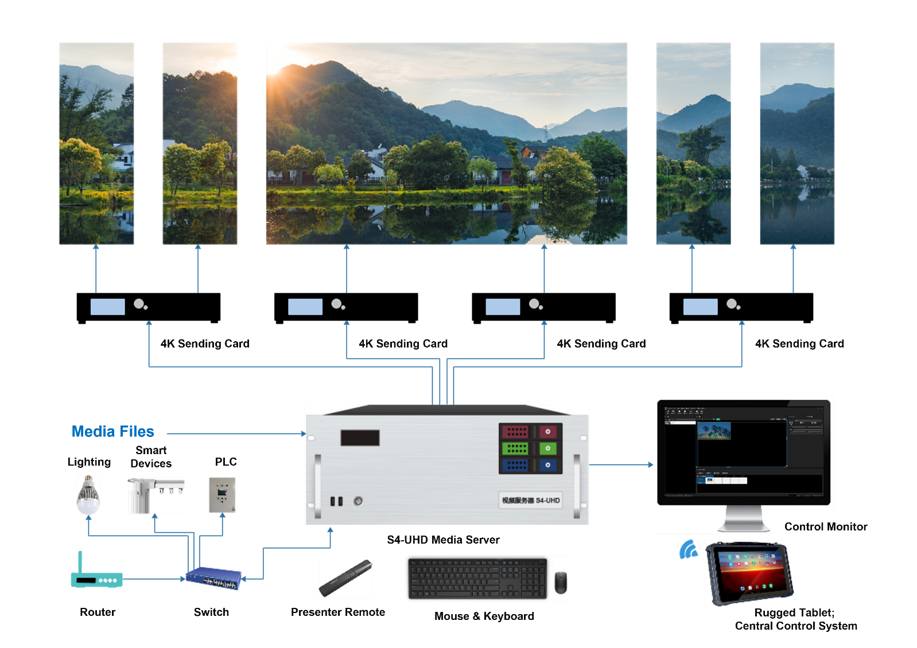

Notes

When using the device, place the device horizontally, do not flip or place it vertically.

The product can be installed in a standard 19-inch cabinet. The cabinet load requirement is at least four times the weight of all equipment in the cabinet. It needs to be installed with 4 M5 panel screws.

**Statement and Warning**

This is A Class A product, which may cause radio interference in a domestic environment. In such cases, users may be required to take practical measures against their interference.

**Copyright ©2024 Shenzhen Ruizhong Technology Co., LTD. All rights reserved.**

Without the permission of the Company, any unit or individual shall not copy, copy part or all of the content of the text document without authorization, and shall not be transmitted in any form.

**Trademark declaration**

 is a registered trademark of Ruizhong Technology.

**Statement**

We strive to be accurate and reliable in the preparation of documentation, and the content may be modified or changed at any time without notice.If you encounter any problems during use, please contact us according to the contact information in the document, and we will try our best to support you.

**Website: www.sz-ipc.com**

**Address: 301, Building 1, No. 2, Shouhe Road, Jinsha Community, Keng Zi Street, Pingshan District, Shenzhen**