

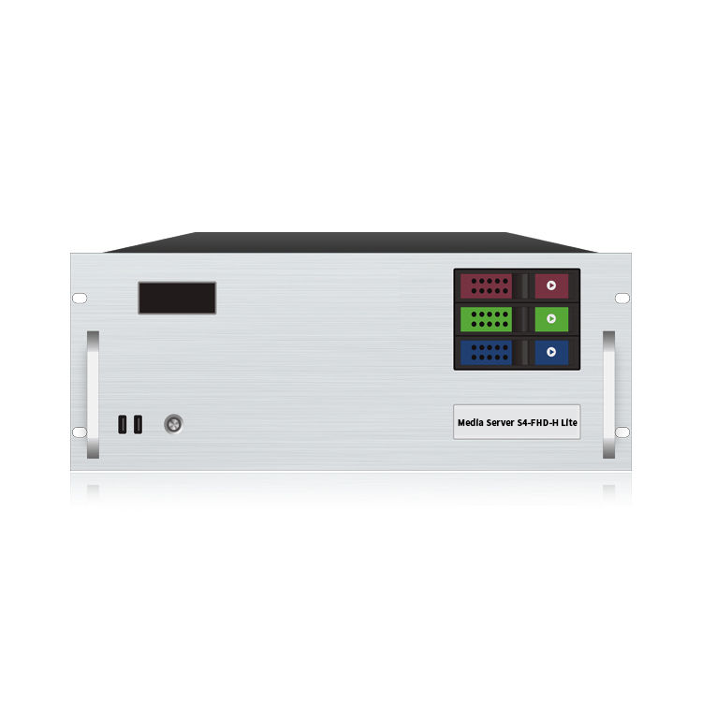

Specification Document

**S4-FHD-H Lite**

**Media Broadcast Control Server**

**Product Introduction**

S4-FHD-H Lite media broadcast control server is a multimedia integrated broadcast control server for large-scale LED broadcast control scene applications such as multimedia exhibition halls, banquet halls, and live performances. It has the signal processing capabilities of traditional multi-screen splicing processors, and integrates the media editing and broadcasting functions and lighting choreography control functions of professional stage performances. It can not only complete high-quality ultra-large resolution point-to-point display, but also realize a variety of display ideas. The S4-FHD-H Lite media broadcast control server is equipped with professional LED broadcast control software, providing users with convenient scene management and professional LED human-computer interaction interface, which is suitable for performing arts, exhibitions, large-scale buildings and various creative display application scenarios.

**Certification**

CCC、CE、Rohs

If the product does not have the relevant certification of the country or region to which it is sold, please contact us for confirmation or processing as soon as possible, otherwise, if the relevant legal risks are caused, the customer shall bear it or we have the right to recover.

**Product Features**

1. Supports 4 HDMI 2.0 video output interfaces, with each channel supporting up to 4096x2160@60Hz.
2. Supports HDMI IN for video signal capture input, with a maximum resolution of 4096x2160@60Hz.
3. Supports point-to-point display, with a maximum of 9.43 million pixels (4U chassis).
4. Supports Gigabit Ethernet port, with direct internet access via a network cable.
5. Supports color adjustments, including RGB color saturation adjustments.
6. Supports PPT playback with two modes: image and animation.
7. Supports connection to the central control system, allowing control of the large screen through the central control.
8. Supports long text playback, including long text over 16,384 characters, with anti-aliasing for transparent background text.
9. Supports screen windowing, allowing the screen to be divided into three, five, or any custom split modes.
10. Supports adding subtitles, with options to adjust size, color, position, and direction or speed of scrolling subtitles.
11. Supports streaming of rtsp, rtmp, http, and https formats, with pre-caching of media frames to improve playback stability.
12. Supports flexible switching of video material color ranges between 0-255 or 16-235, adapting to different displays or lighting environments.
13. Stores up to 100 scene presets, with simultaneous scene recall, scene polling, and features like scheduled or sequential automatic recall based on display needs.
14. Supports custom text artistic effects, including adding fill, shadows, outlines, and backgrounds, with options for texture or gradient effects.
15. Supports output rotation, with options to rotate the image by 90°, 180°, or 270°, and supports stitching after rotation.
16. Supports network wake-up, auto power-on upon connection, and scheduled shutdowns, with software for scheduled tasks like software startup/shutdown/reboot, server shutdown/reboot, play, pause, stop, etc., enabling unattended operation. It can be set to auto-start upon power-on, schedule shutdowns, and automatically open and play the last project on restart.

**Product Dimensions**

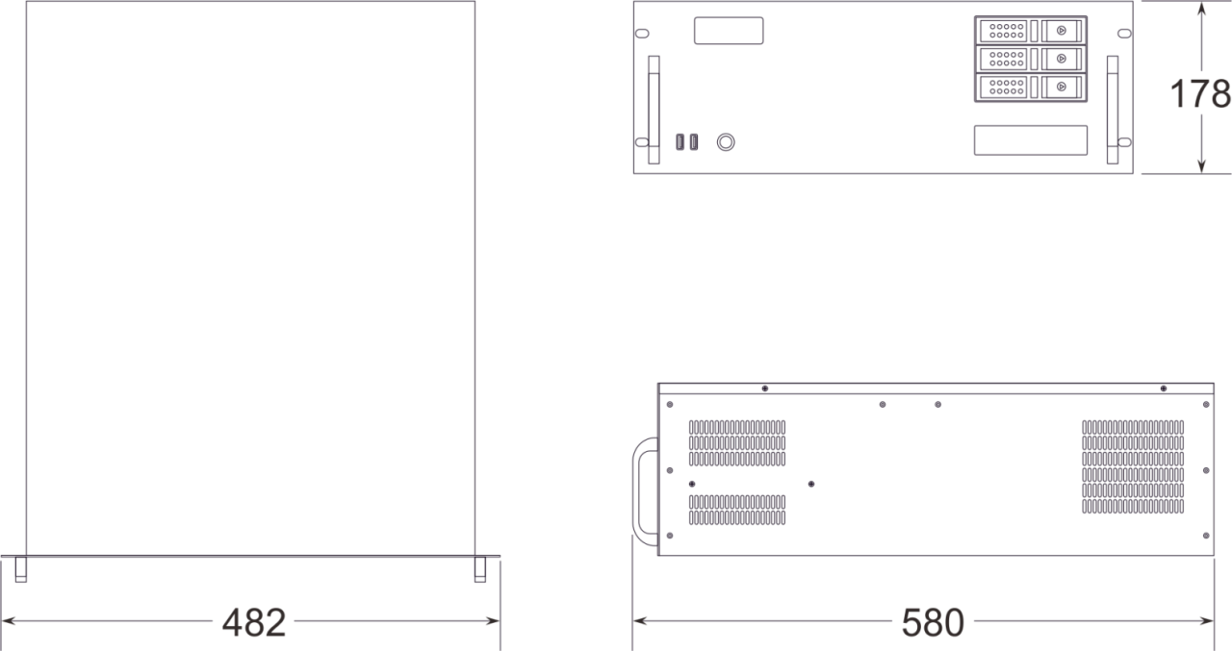

**Product Appearance**

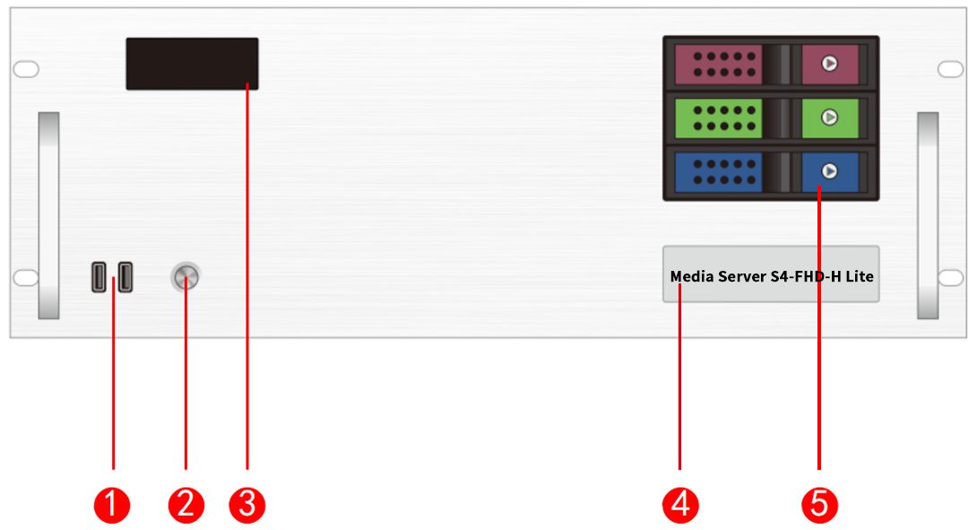

Front Panel

|  |  |  |  |
| --- | --- | --- | --- |
| Index | Interface | Quantity | Illustrate |
| 1 | USB | 2 | • Type-A USB3.0 *2  • Connectable to mouse, keyboard |
| 2 | Switch buttons | 1 | • Switch button |
| 3 | Temperature control display screen | 1 | • Displays server runtime, temperature, fan status, abnormal alarms |
| 4 | Identification | 1 | • Server model and name identification |
| 5 | Front hard drive bay | 3 | • Installable with 3.5-inch, 2.5-inch SATA interface hard drives |

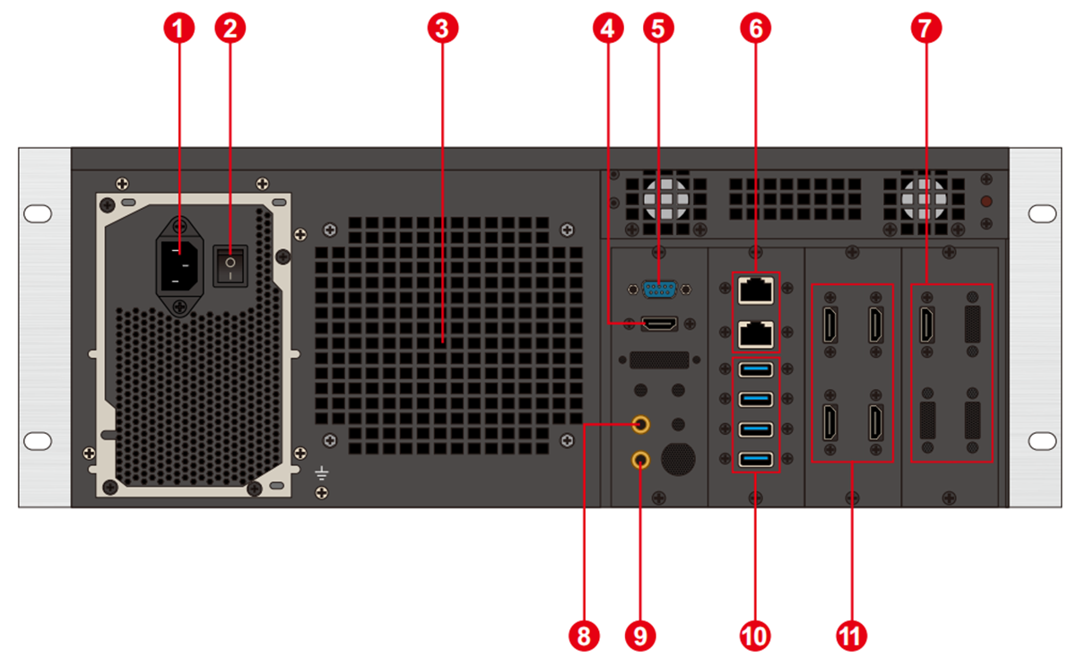

Back Panel

|  |  |  |  |
| --- | --- | --- | --- |
| Index | Interface | Quantity | Illustrate |
| 1 | Power input | 1 | • Power input  • 110V-240V 50/60Hz  • AC power |
| 2 | AC switch | 1 | • Power master switch |
| 3 | Heat vents | 1 | • CPU liquid cooling radiator fan heat dissipation port |
| 4 | HDMI output | 1 | • Connect to HDMI monitor  • Used for operating editing and control software |
| 5 | COM port | 1 | • COM interface  • Connects to RS232/485 protocol serial port devices |
| 6 | Network ports | 2 | • 1GB RJ45 ports |
| 7 | HDMI input | 1 | • Connects to HDMI signal input  • Maximum resolution 1920*1080 |
| 8 | Audio output | 1 | • 3.5mm standard audio output |
| 9 | Microphone | 1 | • 3.5mm standard audio output  • Connects to microphone input audio  • Accepts audio timecode |
| 10 | USB | 4 | • Type-A USB3.0 *4  • Connects to mouse, keyboard, USB drive, external hard drive, wireless network card, etc. |
| 11 | HDMI 2.0 output | 4 | • Connects to monitor for displaying software editing interface  • Connects to sending card or display screen for outputting images  • Maximum output 4096*2160@60Hz |

**Device Hardware/Software**

|  |  |  |  |
| --- | --- | --- | --- |
| **Hardware Parameters** | | | |
| CPU | Intel® Xeon® E-2174G processor 8M cache, base frequency 3.8GHz, turbo frequency up to 4.70 GHz | | |
| Memory | 16GB DDR4 | | |
| Storage | 500GB SSD solid-state drive, supports additional hot-swappable hard drives | | |
| Output Graphics Card | NVIDIA T1000 4GB professional graphics card | | |
| Control Graphics Card | INTEL P630 | | |
| Power supply | Great Wall 650W | | |
| Chassis | 4U hot-swappable chassis | | |
| Radiator | Water-cooled (CPU), air-cooled (GPU) | | |
| **Software** | | | |
| Operating system | Windows 10 Enterprise | Broadcast Control System | LED Broadcast Control System (Window Version) |
| **Power supply** | | | |
| Input Power | 110-220V AC ~ 50Hz | | |
| Maximum Power | 650W | | |

**Equipment Specifications**

|  |  |
| --- | --- |
| Electrical Specifications | 110-240V~ 6A 50/60Hz ；650W maximum power |
| Installation Specifications | 4U rack-mounted installation (according to the site situation). |
| Dimensions | 580mm (length) × 482mm (width) × 178mm (height) |
| Working environment | Temperature: 5-35°C (40°-95°F), Humidity: 5%-95% (non-condensing). |
| Storage environment | -10℃～+60℃ ；0%RH～95%RH，non-condensing |
| Package size | 678mm (length) × 548mm (width) × 265mm (height). |
| Fittings | Power cord *1, Ethernet cable *1, Inspection report *1, Test report *1, Certificate of conformity *1, Packing list *1, Mouse and keyboard set *1, Wireless network card *1,HDMI cable*5、Activation label *1 (attached to the front panel of the chassis) |

**Media Type**

|  |  |
| --- | --- |
| **Media Type** | **Media Format** |
| Video | mp4、avi、mkv、flv、mov、wmv、mpeg、mpg、m4v、webm、HAP |
| Audio | mp3、aac、flac、amr、ape、wav、wma |
| Image | jpg、jpeg、bmp、png、gif、ico |
| Text | Txt |
| Streaming | Ndi、http、rtsp、rtp、rtcp、rtmp、mms、hls |
| Web page | Support access to any web page |
| Office files | PPT (1080P) |

 Notes

Video encoding format recommendation:

• If the video is between 4K and 8K in size, with a width of 8192 or less and a height of 4320, H.265 (HEVC) or VP9 encoding is recommended.

• When the video is 4K or smaller, H.264 (AVC) encoding is recommended.

• If the video is over 8K and the width is not more than 15,360 and the height is not more than 7,680, it is recommended that the video be encoded in HAP.

For the best performance and image quality, the recommended video source bitrate is as follows:

|  |  |  |
| --- | --- | --- |
| **Video resolution** | **24-30 fps (standard video)** | **48-60 fps (high frame video)** |
| 4320P(8K) | 70-100Mbps | 100-140Mbps |
| 2160P(4K) | 35-45Mbps | 55-70Mbps |
| 1080P(2K) | 10Mbps | 16Mbps |

The above is the recommended video bitrate for SDR sources.

**Function Support**

|  |  |
| --- | --- |
| **Function** | **Description** |
| Media support | Supports playback of various media such as PPT, web pages, videos, images, and audio |
| 3D WEB broadcast control system | Supports multi-terminal control |
| 24-244 Frame Rate Selection (Frame Interpolation Playback) | Supports |
| Central Control System (Standard Version) | Supports |
| Preview Monitoring System | Supports |
| Interactive games | Supports |
| NDI Capture | Supports |
| Streaming Media Playback | Supports |
| LTC/NTC Timecode | Supports receiving and sending timecode |
| DMX512 | Supports recording, playback, and control of DMX512 signals |
| TCP/UDP Protocol | Supports sending TCP/UDP control commands and receiving TCP/UDP control commands |

**装箱清单**

|  |  |  |  |
| --- | --- | --- | --- |
| Item | Quantity | Specification | Unit |
| Server | 1 | S4-FHD-H Lite | Unit |
| Power cord | 1 | 1.8 meters | Strip |
| HDMI cable | 5 | 2 meters | Strip |
| Wireless network card | 1 | USB wireless network card | Piece |
| Keyboard and mouse | 1 | Dual delphinium USB keyboard mouse | Set |
| Certificate | 1 |  | Copy |
| Test report | 1 |  | Copy |
| Functional checklist | 1 |  | Copy |
| Packing list | 1 |  | Copy |

 **Notes**

When using the device, place the device horizontally, do not flip or place it vertically.

The product can be installed in a standard 19-inch cabinet. The cabinet load requirement is at least four times the weight of all equipment in the cabinet. It needs to be installed with 4 M5 panel screws.

**Statement and Warning**

This is A Class A product, which may cause radio interference in a domestic environment. In such cases, users may be required to take practical measures against their interference.

**Copyright ©2024 Shenzhen Ruizhong Technology Co., LTD. All rights reserved.**

Without the permission of the Company, any unit or individual shall not copy, copy part or all of the content of the text document without authorization, and shall not be transmitted in any form.

**Trademark declaration**

is a registered trademark of Ruizhong Technology.

**Statement**

We strive to be accurate and reliable in the preparation of documentation, and the content may be modified or changed at any time without notice. If you encounter any problems during use, please contact us according to the contact information in the document, and we will try our best to support you.

**Website: www.sz-ipc.com**

**Address: 301, Building 1, No. 2, Shouhe Road, Jinsha Community, Keng Zi Street, Pingshan District, Shenzhen**