

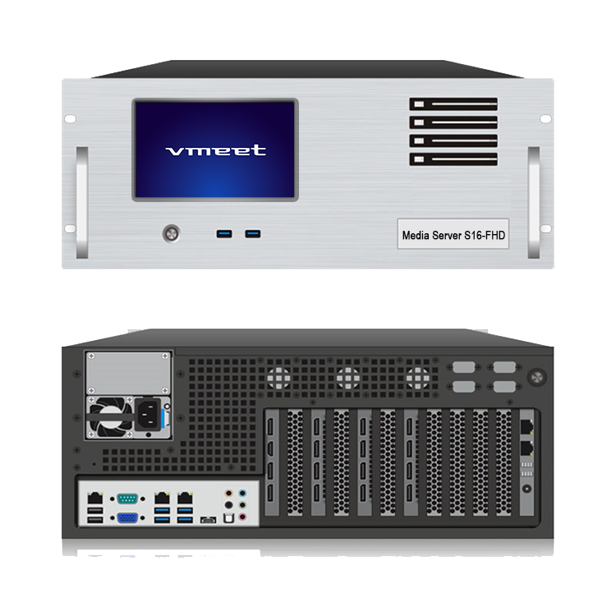

**Media Broadcast Control Server**

Specification Documents

**S16-FHD**

**Revision History**

|  |  |  |
| --- | --- | --- |
| Release Version | Release Date | Update Notes |
| V1.0 | 2022-11-29 | • First release |
| V1.1 | 2024-07-23 | • Graphics card upgraded to NVIDIA Quadro RTX4000ada*4  • CPU changed to W5-3425, memory changed to 128GB  • Memory upgraded to 128GB RECC DDR5-4800 (8 channels) |

**Product Introduction**

S16-FHD media broadcast control server is a multimedia integrated broadcast control server for large-scale LED broadcast control scenarios such as multimedia exhibition halls, banquet halls, and live performances. It has the signal processing capability of traditional multi-picture splicing processor, and integrates the media editing function of professional stage performance and the lighting arrangement control function. It can not only achieve high quality and ultra-high resolution point-to-point display, but also achieve a variety of display creativity. S16-FHD media broadcast control server with professional LED broadcast control software, to provide users with convenient scene management and professional LED human-computer interaction interface, suitable for performing arts, exhibitions, large buildings and a variety of creative display application scenarios.

**Certification**

CCC、CE、Rohs

If the product does not have the relevant certification of the country or region where it is sold, please contact Ruizhong Technology to confirm or deal with it at the first time, otherwise, if the relevant legal risks are caused, the customer shall bear the responsibility or Ruizhong Technology has the right to recover.

**Product Features**

* GPU supports 2 encoding engines, 2 decoding engines (including AV1 encoding) and decoding engines.
* The system supports a total pixel load of 141.55 million pixels, with a maximum width of 16384Px and a maximum height of 16384Px.
* The system supports 16 DP1.4 rendering outputs, backward compatible with DP1.2.
* The system supports 16K ultra-high-resolution desktop fusion and multi-screen splicing.
* Supports 8K video hardware decoding and 16K HAP image sequence frame decoding.
* Supports HDR 10bit/12bit/16bit and simulated HDR effects.
* Supports custom resolution output and EDID lock on ports to prevent display order errors on external displays.
* Supports direct control of playback from a tablet without a central control host.
* Supports streaming media, NDI, PPT, multi-web dynamic playback, executable program playback, and simple folder playback.
* Supports professional video formats such as HAP, DXV, HEVC, etc.
* Supports decoding of image sequences in jpg, jpeg, bmp, png, gif, and ico formats.
* Supports extended external signal acquisition, such as SDI/DVI/HDMI/CVBS (optional).
* Supports TCP/UDP network commands.
* Supports monitoring the server's operating status on a secondary screen and performing routine operations like restarting and shutting down.
* Built-in touch monitoring secondary screen, supporting customization of control function buttons according to project needs.
* Supports multi-scheduled task triggering, activating different scheduled tasks based on different program windows and dates.
* Supports various special effects such as seamless scaling, free rotation, feathering, cropping, and mosaic for material playback.
* Supports multiple playback control methods such as roaming, overlay, zooming, stretching, and picture-in-picture display.
* Built-in interactive engine, supporting single-channel (radar) with upgrade options to multi-channel radar engine.
* Built-in gesture control interactive program, allowing program switching, volume adjustment, and simulating mouse movements and clicks using a standard USB camera.
* Built-in simulated high-resolution KVM control program, supporting low-resolution displays.

**Product Dimensions**

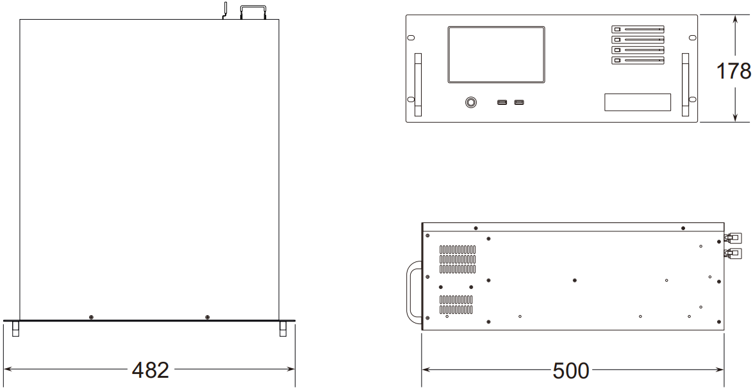

**Product Appearance**

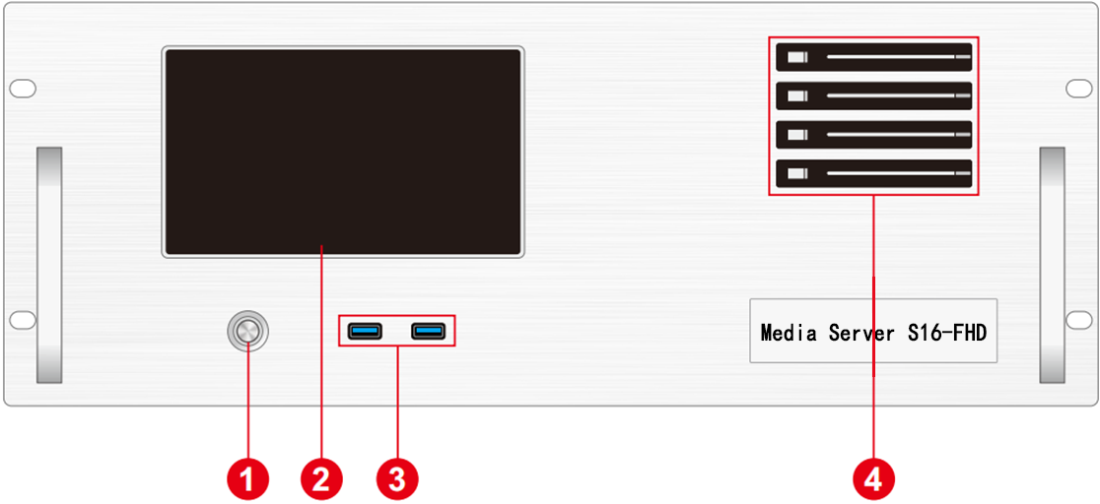

Front Panel

|  |  |  |  |
| --- | --- | --- | --- |
| Serial No. | Interface | Quantity | Description |
| 1 | Switch on/off button | 1 | • Turn on or off |
| 2 | 7 inch touch screen | 1 | • Display server information, status |
| 3 | USB | 2 | • Front-facing USB3.0 interface |
| 4 | Front Hard Drive | 1 | • Supports 2.5-inch SATA interface HDD or SSD |

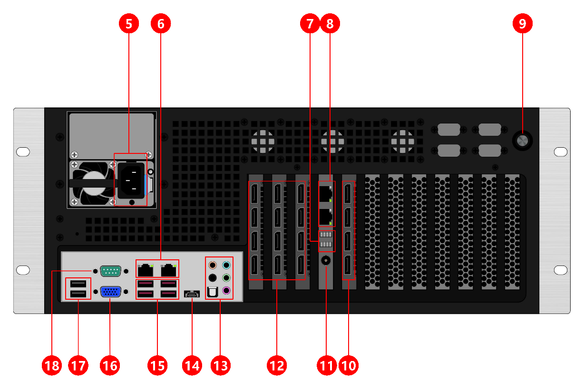

Back Panel

|  |  |  |  |
| --- | --- | --- | --- |
| Serial No. | Interface | Quantity | Description |
| 5 | Power supply input | 1 | • AC 220-240 AC 50/60Hz |
| 6 | RJ45 port | 1 | • Network port *2 |
| 7 | Sync card indicator light | 1 | • Synchronization card status indicator |
| 8 | Synchronous card FL interface | 1 | • Used for cascading between synchronous cards |
| 9 | BIOS Reset key | 1 | • BIOS settings reset button (optional) |
| 10 | DP output | 4 | • DP1.4 output |
| 11 | Frame synchronization signal input | 1 | • External frame synchronization signal input |
| 12 | DP output | 12 | • DP1.4 output |
| 13 | Audio | 1 | • Rear 7.1 sound card 3.5 mm audio interface |
| 14 | Type-C | 1 | • Type-C port |
| 15 | USB | 4 | • USB3.2*4 |
| 16 | VGA | 1 | • Debug port |
| 17 | USB | 2 | • USB3.2*2 |
| 18 | COM | 1 | • COM port |

**Device Hardware/Software**

|  |  |  |  |
| --- | --- | --- | --- |
| **Hardware Parameter** | | | |
| CPU | Intel® Xeon® W5-3425, 12 cores and 24 threads, main frequency 3.20GHz, turbo frequency 4.60GHz | | |
| Memory | 128 GB RECC DDR5-4800（8 channels） | | |
| Storage | 2TB Nvme pcie4.0 SSD，2.5-inch hot-swappable hard disk can be installed. | | |
| Output graphics card | NVIDIA RTX4000 Ada *4，single GPU precision (FP32) 26.7TFLOPs, CUDA core number 6144 | | |
| Synchronization card | NVIDIA SYNC II Synchronization card | | |
| M.2 | 4*PCIe4.0 NVMe x4 Internal Port(s) , support M.2group Raid0,1,5,10 | | |
| Collection card | Support HDMI/DVI/SDI multiple signal input 2K/4K custom capture card (optional) | | |
| Power supply | 1150W server power supply (expandable to 1+1 redundant power supply) | | |
| **Software** | | | |
| Operating system | Windows 11 Professional Workstation Edition | Broadcast control system: | LED broadcast control system (window version) |
| **Power Source** | | | |
| Input power supply | 220-240V AC ~ 50/60hz | | |
| Maximum power | 1150W | | |

**Equipment Specification**

|  |  |
| --- | --- |
| Electrical specification | 220-240V~ 6A 50/60Hz; 1250W maximum power |
| Installation specification | 4U rack mounting (based on site conditions) |
| Size specification | 482㎜(w)*178㎜(H)*500㎜(D) |
| Working environment | Temperature: 5-35°C (40°-95°F), humidity: 5%-95% (non-condensing) |
| Storage environment | -10℃ ~ +60℃; 0%RH to 95%RH, non-condensing |
| Package size | 678㎜(length)×548㎜(width)×265㎜(height) |
| Accessories | Power cable *1, network cable *1、functional checklist*1、Test Report*1、certificate *1, packing list *1, mouse and keyboard set *1, wireless network card *1, DP cable *16,、HDMI cable*1、activation label *1 (attached to the front panel of the chassis) |

**Media Type**

|  |  |
| --- | --- |
| **Media Type** | **Media Format** |
| Video | mp4、avi、mkv、flv、mov、wmv、mpeg、mpg、m4v、webm、HAP |
| Audio frequency | mp3、aac、flac、amr、ape、wav、wma |
| Picture | jpg、jpeg、bmp、png、gif、ico |
| Text | Txt |
| Streaming media | Ndi、http、rtsp、rtp、rtcp、rtmp、mms、hls |
| WEB | Supports access to any web page |
| Office file | PPT（1080P） |

Notes

说明：

Video encoding format recommended:

• When the video size is above 4K, 8K or below, and the width does not exceed 8192 and the height does not exceed 4320, it is recommended to use H.265 (HEVC) encoding or VP9 encoding.

• When the video is 4K or below, H.264 (AVC) encoding is recommended.

• HAP encoding is recommended when the video is larger than 8K and the width is less than 15360 and the height is less than 7680.

For the best performance and picture quality, the recommended video source rate is as follows:

|  |  |  |
| --- | --- | --- |
| **Video resolution** | **24-30 FPS (standard video)** | **48-60 FPS (high frame video)** |
| 4320P（8K） | 70-100Mbps | 100-140Mbps |
| 2160P（4K） | 35-45Mbps | 55-70Mbps |
| 1080P（2K） | 10Mbps | 16Mbps |

The above is the recommended video bit-rate for SDR source.

**Functional support**

|  |  |
| --- | --- |
| **Feature** | **Description** |
| Mutual active and standby | Supports automatic active/standby switchover |
| Media support | Support PPT, web pages, videos, pictures, audio and other media playback |
| Slice mask | Supports the import of slice data and mask function |
| Matting function | Support chroma matting, support custom color matting |
| cascade | Support multi-machine cascade control |
| Frame synchronization | Support (upgrade required) |
| 3D WEB broadcast control system | Supports multi-terminal control |
| 24-244 Frame rate selection (Insert frame playback) | support |
| Central control System (Standard Edition) | support |
| The monitoring system is displayed | support |
| Interactive game | support |
| NDI acquisition | support |
| Streaming media | support |
| LTC/NTC time code | Supports receiving and sending time codes |
| DMX512 | Support recording playback and broadcast control by DMX512 signal control |
| TCP/UDP protocol | You can send and receive TCP/UDP control commands |

**Packing List**

|  |  |  |  |
| --- | --- | --- | --- |
| Item | Quantity | Quantity | Unit |
| Mainframe | 1 | S16-FHD | Unit |
| Power cord | 1 | 1.8m | Strip |
| HDMI cable | 1 | 2m | Strip |
| DP line | 16 | 2m | Strip |
| Wireless network card | 1 | USB wireless card | Piece |
| Keyboard and mouse | 1 | Dual Swift USB keyboard and mouse | Set |
| Certificate | 1 |  | Copy |
| Test report | 1 |  | Copy |
| Functional checklist | 1 |  | Copy |

**Notes**

When using the device, place it horizontally. Do not turn it over or place it vertically.

The product can be installed in a 19-inch standard cabinet. The cabinet must bear at least four times the weight of all the devices in the cabinet. Use four M5 panel screws to secure the installation.

**Statement and Warning**

This is A Class A product, which may cause radio interference in a domestic environment. In such cases, users may be required to take practical measures against their interference.

**Copyright ©2024 Shenzhen Ruizhong Technology Co., LTD. All rights reserved.**

Without the permission of the Company, any unit or individual shall not copy, copy part or all of the content of the text document without authorization, and shall not be transmitted in any form.

**Trademark declaration**

is a registered trademark of Ruizhong Technology.

**Statement**

We strive to be accurate and reliable in the preparation of documentation, and the content may be modified or changed at any time without notice.If you encounter any problems during use, please contact us according to the contact information in the document, and we will try our best to support you.

**Website: www.sz-ipc.com**

**Address: 301, Building 1, No. 2, Shouhe Road, Jinsha Community, Keng Zi Street, Pingshan District, Shenzhen**