

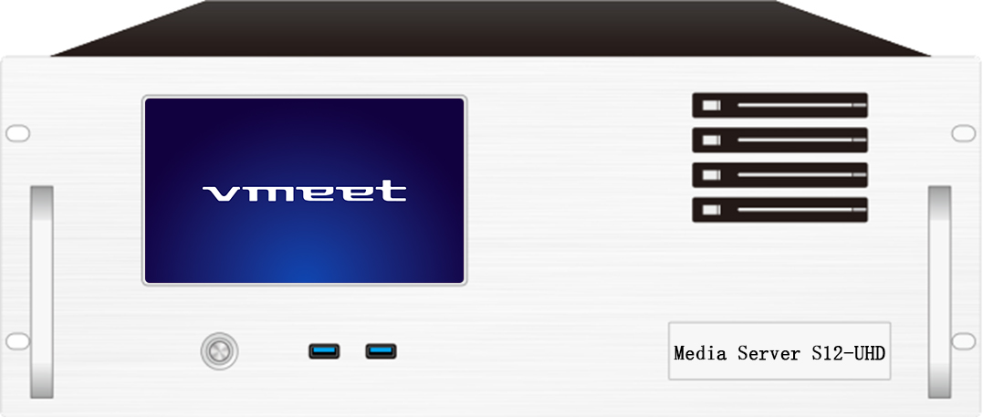

**Media Broadcast Control Server**

Specification Documents

**S12-UHD**

**Revision History**

|  |  |  |
| --- | --- | --- |
| Release Version | Release Date | Update Notes |
| V1.0 | 2021-08-31 | • First release |
| V1.1 | 2022-06-15 | • Update the power/graphics /VGA/COM port |
| V1.2 | 2022-09-06 | • Updated appearance parameters/System description |
| V1.3 | 2023-05-22 | • Add a T1000 graphics card as a display  • Change the broadcast control system to window version |

**Product Introduction**

S12-UHD video server is a multimedia integrated broadcast control server for large-scale LED broadcast control scenarios such as multimedia exhibition halls, banquet halls, and live performances. It has the signal processing capability of traditional multi-picture splicing processor, and integrates the media editing function of professional stage performance and the lighting arrangement control function. It can not only achieve high quality and ultra-high resolution point-to-point display, but also achieve a variety of display creativity. S12-UHD video server with professional LED broadcast control software, to provide users with convenient scene management and professional LED human-computer interaction interface, suitable for performing arts, exhibitions, large buildings and a variety of creative display application scenarios.

**Certification**

CCC、CE、Rohs

If the product does not have the relevant certification of the country or region where it is sold, please contact Ruizhong Technology to confirm or deal with it at the first time, otherwise, if the relevant legal risks are caused, the customer shall bear the responsibility or Ruizhong Technology has the right to recover.

**Product Features**

* Single outlet with maximum load width 8192Px, maximum height 8192Px, in the range of 8.84 million Px user-defined.
* The machine carries up to 99 million pixels and supports customization.
* Supports multi-channel 8K/4K/2K hardware decoding capabilities.
* Video input: 4K/2K input is optional.
* Number of input channels: 1-4 HDMI/DVI/SDI Optional.
* Supports multiple HDMI/DVI/SDI signal input 2K/4K custom acquisition card (optional).
* Support tablet central control playback.
* Supports TCP/UDP network commands.
* Supports screen rotation at any Angle, suitable for a variety of creative display applications.
* LTC Time code synchronization.
* 1000W server power supply.
* 3D mapping.
* Built-in universal decoder, can decode HAP, DXV, HEVC and other common and professional video formats.

**Product Dimensions**

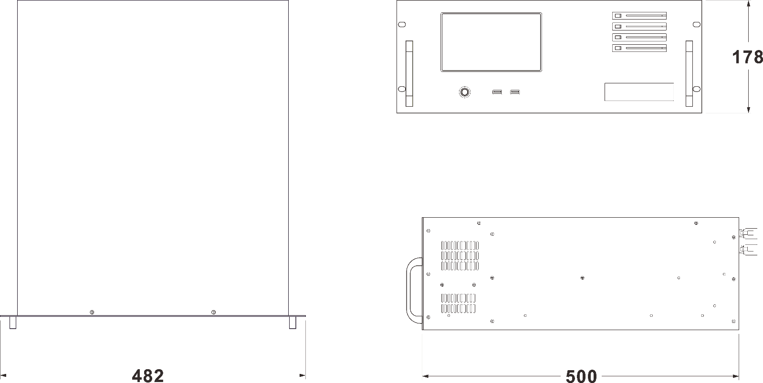

**Product Appearance**

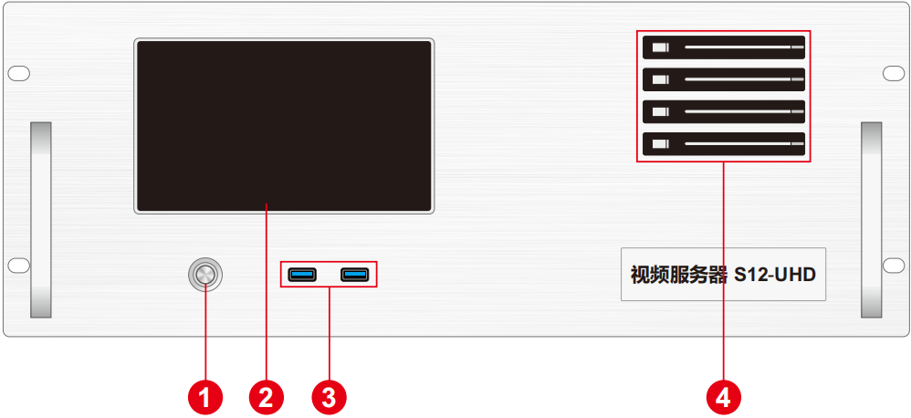

Front Panel

|  |  |  |  |
| --- | --- | --- | --- |
| Index | Interface | Quantity | Description |
| 1 | Switch on/off button | 1 | • Turn on or off |
| 2 | 7 inch touch screen | 1 | • Display server information, status |
| 3 | USB | 2 | • Front-facing USB3.0 interface |
| 4 | Front Hard Drive | 4 | • Supports 2.5-inch SATA interface HDD or SSD |

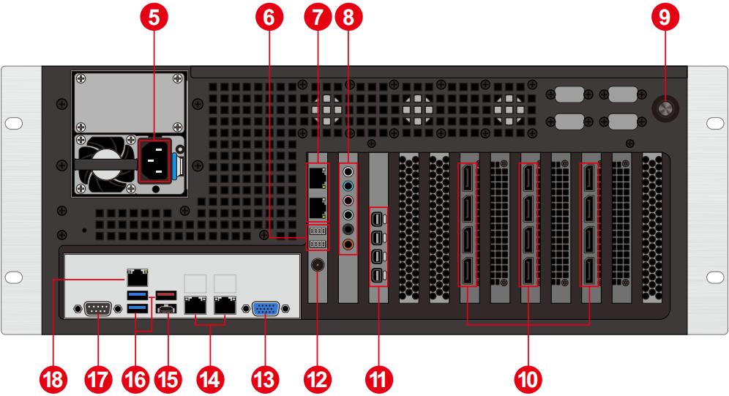

Back panel

|  |  |  |  |
| --- | --- | --- | --- |
| Index | Interface | Quantity | Description |
| 5 | Power supply input | 1 | • AC 220-240 AC 50/60Hz |
| 6 | Sync card indicator light | 2 | • Synchronization card status indicator |
| 7 | Synchronization card FL port | 2 | • Used for synchronization between card cascade |
| 8 | Audio frequency | 6 | • 3.5㎜ Audio and microphone |
| 9 | Reset key | 1 | • BIOS Settings reset/reset |
| 10 | DP output | 12 | • DP1.4 output *12 |
| 11 | Mini output | 4 | • Connecting a monitor |
| 12 | BNC Sync Signal | 1 | • External frame sync signal input |
| 13 | VGA | 1 | • Debug port |
| 14 | RJ45 port | 2 | • Network port |
| 15 | Type-C Port number | 1 | • Type-C port |
| 16 | USB | 3 | • USB3.0 *2 USB3.2 *1 |
| 17 | COM port | 1 | • COM port |
| 18 | IPIM port | 1 | • IPIM management port |

**Device Hardware/Software**

|  |  |  |  |
| --- | --- | --- | --- |
| **Hardware Parameter** | | | |
| CPU | 2*INTEL XEON Gold 6326/32 cores 64 threads/Turbo 3.5GHz | | |
| Memory | 128GB DDR4 RECC | | |
| Storage | 4TB Nvme M.2 SSD with a 2.5-inch hot-swappable hard drive. | | |
| Control graphics card | NVIDIA T1000 | | |
| Output graphics card | 3 * NVIDIA RTX A5000 professional graphics card | | |
| Synchronization card | NVIDIA SYNC II Sync card | | |
| Collection card | Support HDMI/DVI/SDI multiple signal input 2K/4K custom acquisition card (optional) | | |
| Power Supply: | 2000W server power supply (redundancy optional) | | |
| **Software** | | | |
| Operating system: | Windows 10 Enterprise Edition | Broadcast control system: | LED broadcast control system (window version) |
| **Power source** | | | |
| Input power supply: | 220-240V AC ~ 50/60hz | | |
| Maximum power: | 2000W | | |

**Equipment specification**

|  |  |
| --- | --- |
| Electrical specification | 220-240V~ 6A 50/60Hz; 2000W maximum power |
| Installation specification | 4U rack mounting (based on site conditions) |
| Size specification | 500㎜(length)×482㎜(width)×178㎜(height) |
| Working environment | Temperature: 5-35°C (40°-95°F), humidity: 5%-95% (non-condensing) |
| Storage environment | -10℃ ~ +60℃; 0%RH to 95%RH, non-condensing |
| Package size | 678㎜(length)×548㎜(width)×265㎜(height) |
| Accessories | Power cable *1, ethernet cable *1, functional checklist *1, test report *1, certificate *1, packing list *1, mouse and keyboard set *1, wireless network card *1, DP cable *12, miniDP to HDMI cable *1, HDMI cable *1, Activation label *1 (attached to the front panel of the chassis) |

**Media Type**

|  |  |
| --- | --- |
| **Media Type** | **Media Format** |
| Video | mp4、avi、mkv、flv、mov、wmv、mpeg、mpg、m4v、webm、HAP |
| Audio frequency | mp3、aac、flac、amr、ape、wav、wma |
| Picture | jpg、jpeg、bmp、png、gif、ico |
| Text | Txt |
| Streaming media | Ndi、http、rtsp、rtp、rtcp、rtmp、mms、hls |
| WEB | Supports access to any web page |
| Office file | PPT（1080P） |

Notes

Video encoding format recommended:

• When the video size is above 4K, 8K or below, and the width does not exceed 8192 and the height does not exceed 4320, it is recommended to use H.265 (HEVC) encoding or VP9 encoding.

• When the video is 4K or below, H.264 (AVC) encoding is recommended.

• HAP encoding is recommended when the video is larger than 8K and the width is less than 15360 and the height is less than 7680.

For the best performance and picture quality, the recommended video source rate is as follows:

|  |  |  |
| --- | --- | --- |
| **Video resolution** | **24-30 FPS (standard video)** | **48-60 FPS (high frame video)** |
| 4320P（8K） | 70-100Mbps | 100-140Mbps |
| 2160P（4K） | 35-45Mbps | 55-70Mbps |
| 1080P（2K） | 10Mbps | 16Mbps |

The above is the recommended video bit-rate for SDR source

**Functional Support**

|  |  |
| --- | --- |
| **Feature** | **Description** |
| Mutual active and standby | Supports automatic active/standby switchover |
| Media support | Support PPT, web pages, videos, pictures, audio and other media playback |
| Slice mask | Supports the import of slice data and mask function |
| Matting function | Support chroma matting, support custom color matting |
| Cascade | Support multi-machine cascade control |
| Frame synchronization | Support (upgrade required) |
| 3D WEB broadcast control system | Supports multi-terminal control |
| 24-244 Frame rate selection (Insert frame playback) | support |
| Central control System (Standard Edition) | support |
| The monitoring system is displayed | support |
| Interactive game | support |
| NDI acquisition | support |
| Streaming media | support |
| LTC/NTC time code | Supports receiving and sending time codes |
| DMX512 | Support recording playback and broadcast control by DMX512 signal control |
| TCP/UDP protocol | You can send and receive TCP/UDP control commands |

**Packing List**

|  |  |  |  |
| --- | --- | --- | --- |
| Item | Quantity | Quantity | Unit |
| Server | 1 | S12-UHD | Unit |
| Power cord | 1 | 1.8m | Strip |
| HDMI cable | 1 | 2m | Strip |
| Mini DP to HDMI cable | 1 | 0.3m | Strip |
| DP line | 12 | 2m | Strip |
| Wireless network card | 1 | USB wireless card | Piece |
| Keyboard and mouse | 1 | Dual Swift USB keyboard and mouse | Set |
| Certificate | 1 |  | Copy |
| Test report | 1 |  | Copy |
| Functional checklist | 1 |  | Copy |
| Packing list | 1 |  | Copy |

Notes

When using the device, place it horizontally. Do not turn it over or place it vertically.

The product can be installed in a 19-inch standard cabinet. The cabinet must bear at least four times the weight of all the devices in the cabinet. Use four M5 panel screws to secure the installation.

**Statement and Warning**

This is A Class A product, which may cause radio interference in a domestic environment. In such cases, users may be required to take practical measures against their interference.

**Copyright ©2024 Shenzhen Ruizhong Technology Co., LTD. All rights reserved.**

Without the permission of the Company, any unit or individual shall not copy, copy part or all of the content of the text document without authorization, and shall not be transmitted in any form.

**Trademark declaration**

is a registered trademark of Ruizhong Technology.

**Statement**

We strive to be accurate and reliable in the preparation of documentation, and the content may be modified or changed at any time without notice.If you encounter any problems during use, please contact us according to the contact information in the document, and we will try our best to support you.

**Website: www.sz-ipc.com**

**Address: 301, Building 1, No. 2, Shouhe Road, Jinsha Community, Keng Zi Street, Pingshan District, Shenzhen**